**George is nominated for National Pride of Table Tennis award**

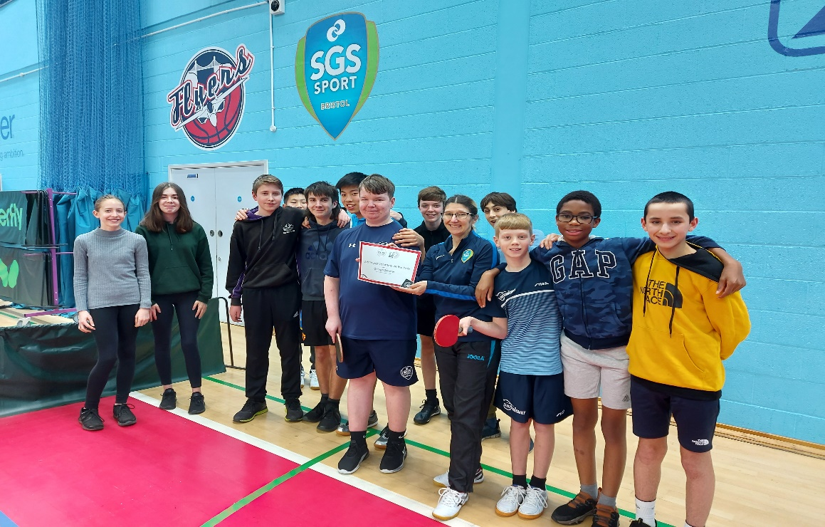

The Table Tennis England “Pride of Table Tennis Awards” celebrates and honours the immense efforts of volunteers and people within the sport, for the incredible contributions to table tennis over the last 12 months.

At the Bristol based South Gloucestershire and Stroud College Community Table Tennis Club the local “Young Club Volunteer of the Year” award from Table Tennis England was awarded to George Stenner. He was presented this by our female community coach Michele Reeves and some of the juniors at one of the weekly coaching sessions that are held by the club.

George has delivered over 50 hours of volunteering this season and said “ I am delighted and honoured to win this award, I find volunteering easy and the fact that people have made an effort to nominate me is something that I will remember. I am just trying to help a little, and make a difference to those that come along to the sessions to make them enjoyable”

The Club is also very lucky as George is part of the Table Tennis England Youth Ambassador programme which has a full mentor programme that helps him to develop within the role, allowing him to help the coaching team and club, making the sessions easier to manage.

“This is just a little recognition of all his hard work and support for all the help he has given the club” said the Head Coach Nick Davidson.

George is also studying sports coaching full time at SGS College and also plays in the local league, so the extra hours he commits leaves him very little spare time and he hopes to join the coaching team over the next year.

Later this month Table Tennis England will announce the National Young Volunteer of the Year award and with George being put forward, we wish him well in this the, centenary year for Table Tennis in England.