1st February 2023

To Club Secretaries

Rules Meeting 2023

Dear Club Secretaries,

The Rules meeting is in the schedule for 20th February.2023

The meeting will take place at The Bristol Civil Service club starting at 7.30pm

Please note that all clubs are required to send a representative to the meeting.

Failure on the part of any club to send a representative will result in a fine being imposed.

Yours sincerely

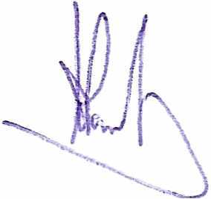

Aylwyn Powell

General Secretary BDTTA

Agenda

1. Chairman’s welcome to delegates
2. Apologies
3. Minutes of September General Meeting
4. Matter Arising
5. Treasurers Report
6. Registration Secretary’s Report including situation on postponements
7. Tournaments
8. Development
9. Junior League and Coaching
10. Rule Change Proposals (see attachement)