**O’Flynn finally makes the summit with the coveted Premiership Singles Title!**

The Lancaster and Morecambe Table Tennis League Annual Tournament took place at the weekend at Morecambe Community High School. The tournament is the most prestigious within the local Table Tennis calendar and this year the Blue Ribbon event prize for the Premier Division singles champion was won by Ben O’Flynn representing Trimpell with Paul Stebbing also from Trimpell as Runner-Up. O’Flynn must have been very satisfied given his history in recent finals, but this year comfortably made it over the finish line onto the Winners Rostrum to take a well deserved victory and most importantly claim the Premiership Singles Champion title!

In the Premiership Doubles O’Flynn partnered with Paul Stebbing to take the doubles title with the University side of Scott Barker/Wesley Burrough as runners up. In the Handicap singles Universities Archie Catnach ran out as victor over Universities Wesley Burrough and into the L&MTTL role of honour.

In the Championship Singles competition we see a new name on the Championship role of honour with newbie James Bowmer from University taking the title with Leea Artin also from University as Championship Singles Runner Up.

Overall University put in a great representation at this years tournament submitting 75% of total entries with Trimpell presenting their biggest stars and St Lukes making minimal representation at this years event, a fact that was reflected in the Trophy haul for each club.

**Premier Singles Winner:**  Ben O’Flynn (Trimpell)

**Premier Singles Runners Up**:   Paul Stebbing (Trimpell)

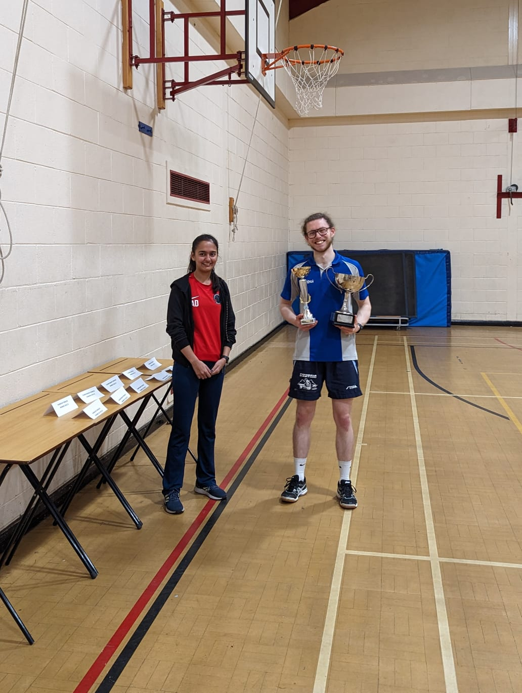

Prem Singles Winner: Ben O’Flynn receiving Trophy from Aditi Dhillon

**Premier Doubles Winners:**Paul Stebbing/Ben O’Flynn (Trimpell)

**Premier Doubles Runners Up:**Scott Barker/Wesley Burrough (University)

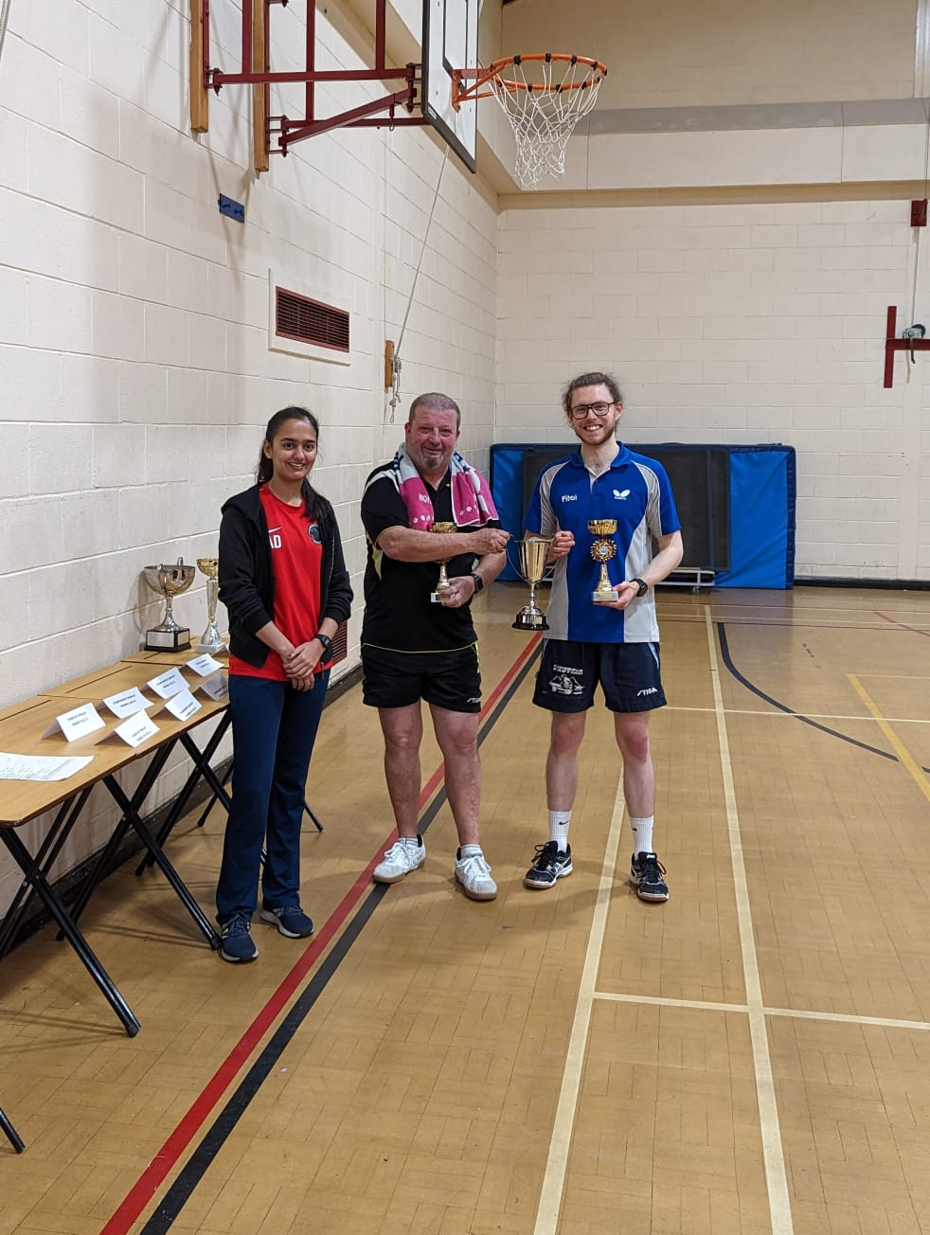

Prem Doubles Winners: Paul Stebbing/Ben O’Flynn receiving Trophy from Aditi Dhillon

**Championship Singles Winner:** James Bowmer (University)

**Championship Singles Runners Up:** Leea Artin (University)

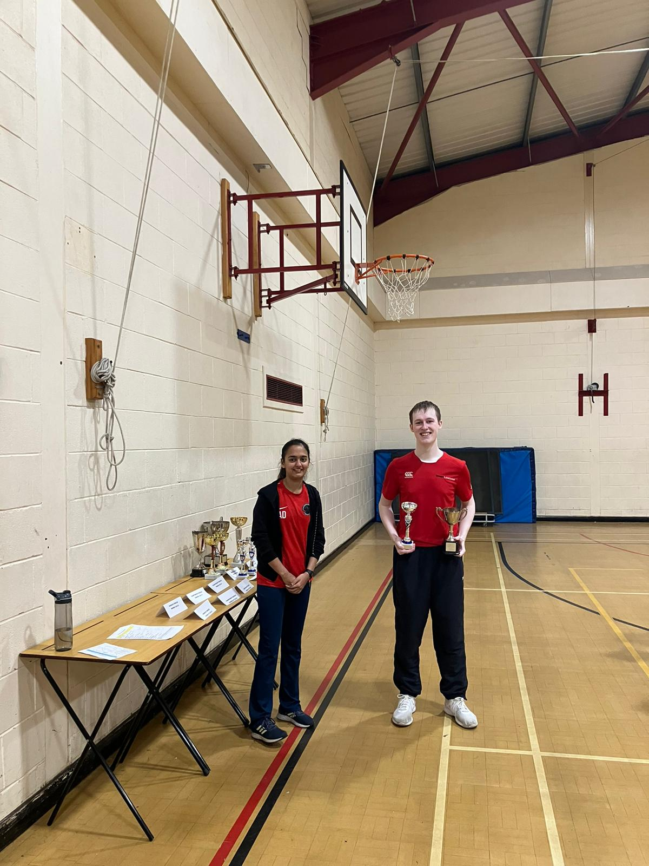

            Championship Singles Winner: James Bowmer receiving Trophy from Aditi Dhillon

**Championship Doubles Winners:** James Bowmer/Leea Artin(University)

**Championship Doubles Runners Up:**Boki Lee/Jay Lo (University)

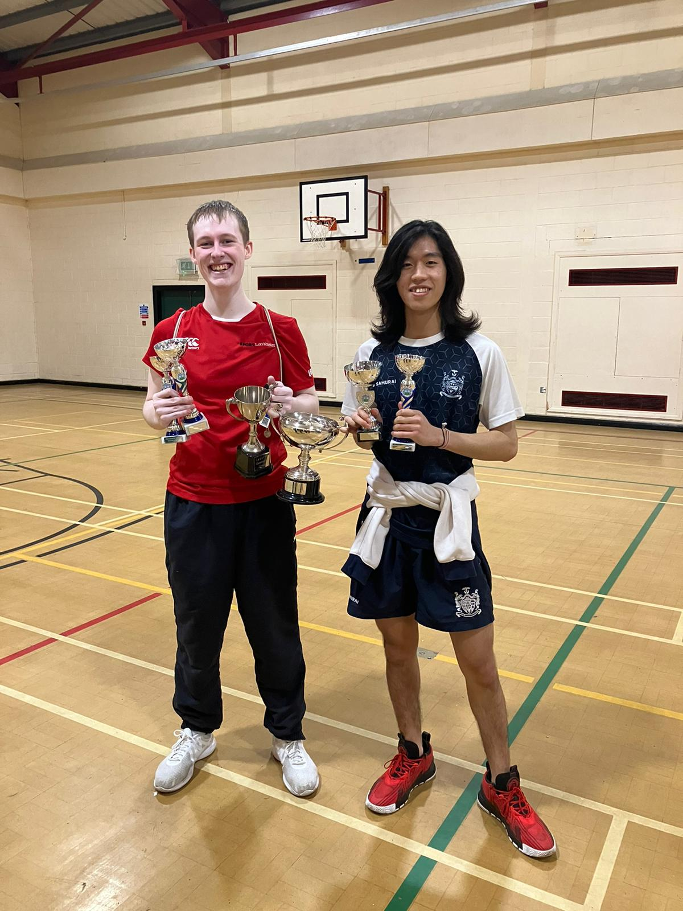

Championship Doubles Winners: James Bowmer/Leea Artin

**Handicap Singles Winner:**Archie Catnach (University)

**Handicap Singles Runners Up:** Wesley Burrough (University)

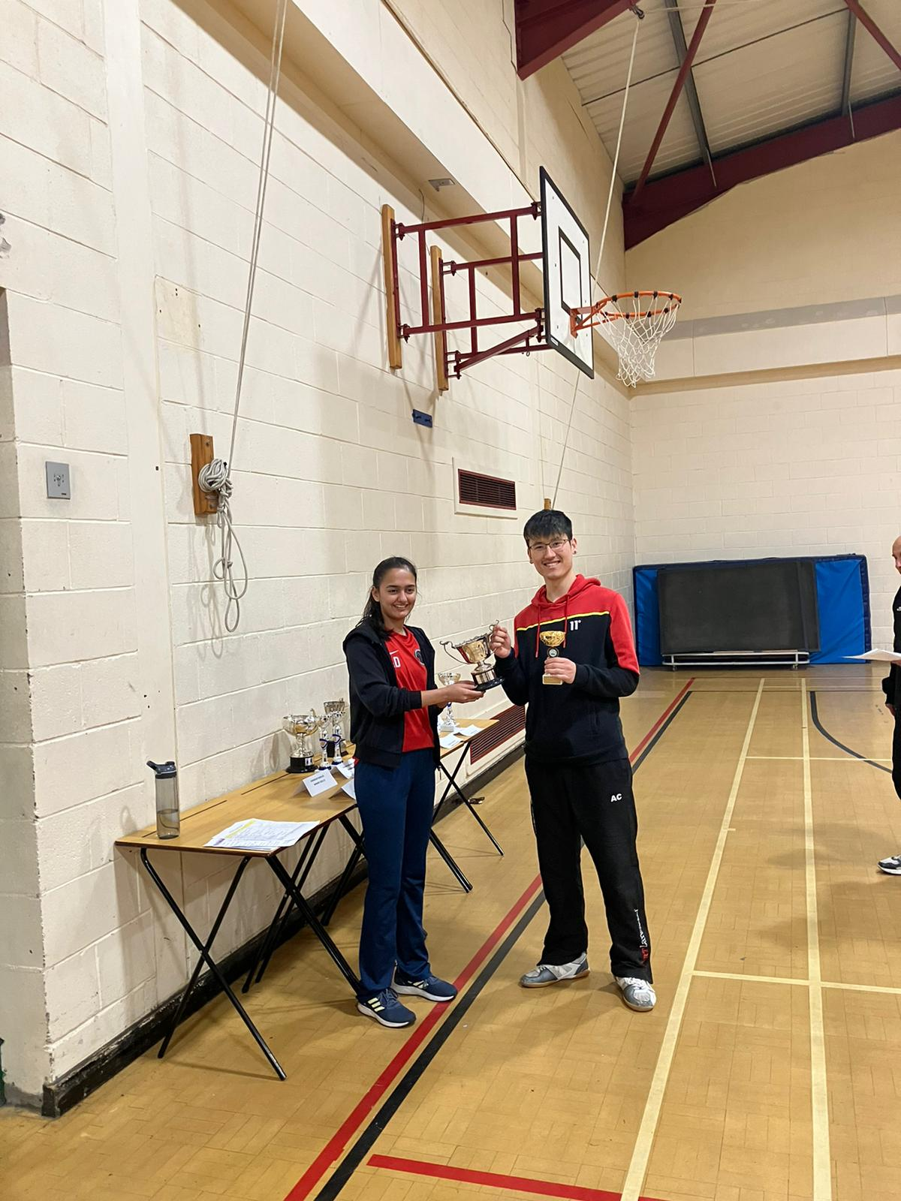

Handicap Singles Winner: Archie Catnach receiving Trophy from Aditi Dhillon

Lancaster University Representatives at this year’s Tournament

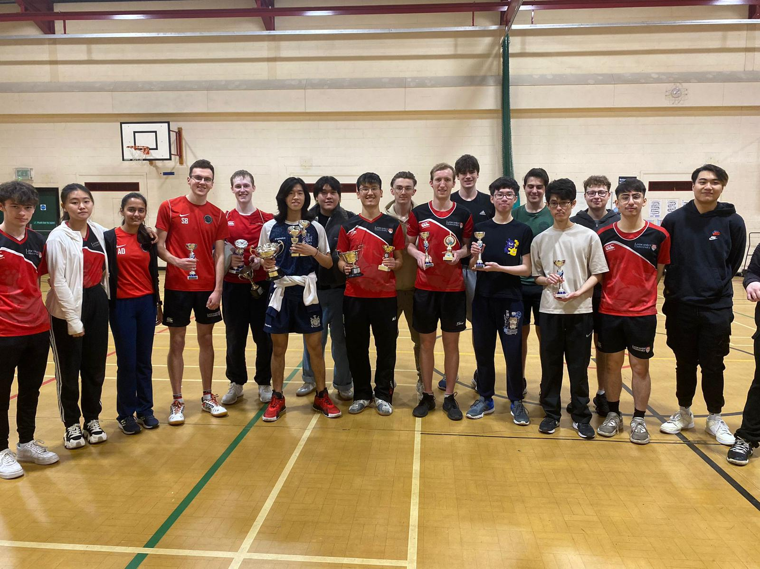Trophy Haul for the Lancaster University Team at this years Tournament with Club Captain/Secretary Scott Barker 4th Left