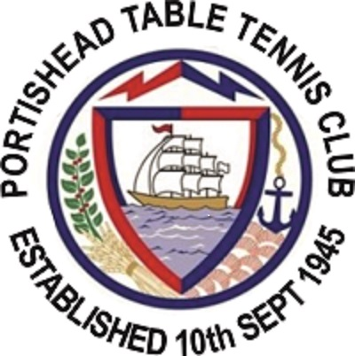
Minutes of the Committee Meeting
Held at Albion on Thursday 30th November 2017 7pm – 9pm
Type of Meeting: Committee Update
Meeting Facilitator: Derek Connop Club Secretary
Attendees Dave Grounsell, Steve Knight, Steve Pratt, Aziz Muscati, Joe Ratajczak, Adam Ratajczak, Ray Jenkins, Derek Connop
Apologies
Steve Doidge, Chris Stone, Michelle Knight
- Open issues, updates
- Financial update.
- Current balance of club funds.
- Provided by Ray
- Any outstanding debts (by this I mean unpaid ones, not brilliant ones ☺ )
- Yes and Ray has requested payment from those responsible
- Discussion on whether we should introduce a half year match fee collection to help cash flow the hire cost of Walton Hall & the Lake Grounds Lease.
- Cashflow allows us to wait until the end of the season to collect all match fees
- Financial update on the Sunday Night Training night. Is it making money ☺ ?
- Yes, since the beginning of the training night the cost of the hall hire is £750 and the money raised in fees (including the amount of prepaid used) is £1317 therefore a profit of £567. We currently have a £725 balance in the prepaid. Since moving to Gordano we have made on average a £67 profit on each session.
- Welfare Officer Update
- Current position with TTE approved DBS cleared members. Who is cleared, who is applying for clearance?
- Cleared members are Dave G and possibly Muz, Steve P to check. To get cleared are Joe, Adam, George, Derek, Mark R & Mo, to tie in with the Grade 1 coaching course they are preparing to do.
- Clearance has to be done though TTE. There is a link to process on their website
- Cost is borne by the individual and not the Club unless the Club specifically requests someone to apply.
- Consent form to allow photographs of juniors to be displayed on social media, FB, Club Website etc.
- Club policy on juniors being unsupervised by a parent at the Sunday Night Training sessions and traveling to games.
- Steve P to look at getting a consent form for parents to sign to cover the points above. In terms of the club policy relating to travel, the default position is that parents escort their children to and from games, if they are unable to do this they can elect the captain of the team their child plays in to escort them or failing that another club member can act as escort so long as they are DBS cleared
- Sunday Night Training
- Open discussion on how we can maximize this resource by opening it up to the wider TT community, by introducing events, structured training sessions, local competitions and exploring outreach project ideas.
- Derek to look into a Club v Club invitation tournament and to report back.
- Joe and Adam to introduce a plan and a structure for training / coaching sessions on Sunday nights
- Introduce a ladder system on the open table part of the Sunday night training to ensure players all play against each other.
- Club Long Term Goals
- Open discussion on what we would ultimately like the club to become.
- Due to time constraints this was put to the next meeting
- Grade 1 Coaching Course
- Talk about what has been agreed with TTE and who is doing it.
- Course dates for the grade 1 coaching course are 21st Jan, 11th March, 8th April and at the moment the people signed up for it are Joe, Adam, Derek, Mo, George & Mark. Steve K might be interested if there is space
- Discuss the clubs financial contribution to the cost of the courses (if any)
- The default position for paying for grade 1 courses is that after applying any and all funding options from 3rd parties any shortfall is met by the individual and not by the club.
- Swapping the table from Gordano to The Lake Grounds
- Make a plan to do this
- This is on hold until we can come up with a system to secure a Joola Table at the Lake Grounds
- Use of Walton Hall update
- How is it going? are the payment arrangements with the Hall working well? Do we have to review it?
- All going well no need to make changes
- Domestic Arrangements At The Lake Grounds
- Talk about the cleaning rota.
- Ray and Steve P to check rota and do the Wednesday in the weeks that it is the Table Tennis Clubs responsibility.
- Club Tshirt
- With the success of the Training Tshirt do we want to make this the Official Match Shirt or do we stay with the current one?
- Leave things as they are but playing league games in the training tshirt is of course fine
- Club Xmas Social idea
16th Dec Posset Cup
- Any other business ☺
Steve P to attend safeguarding courses
- Adjournment

