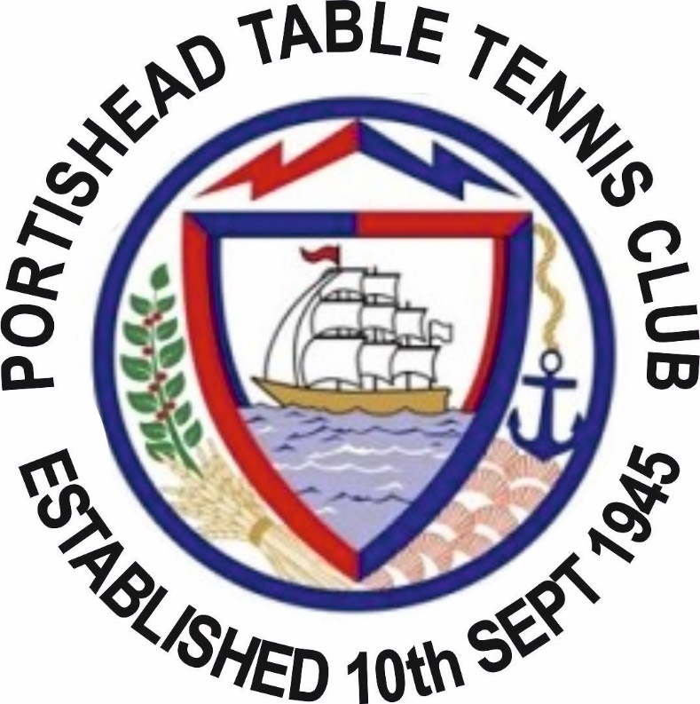

MINUTES OF ANNUAL GENERAL MEETING
PORTISHEAD TABLE TENNIS CLUB
2nd SEPTEMBER 2017

- Approve the minutes of the previous year’s AGM

The minutes were approved without any requests for alterations

- Receive Chairman’s Report

The chairman gave his report thanking all those who have contributed to the running of the club.

- Receive General Secretary’s Report

The secretary gave his report with included some statistics on the season just gone. A copy of that report is attached to these minutes.

- Receive a report from the Treasurer and approve the Annual Accounts

The treasurer gave his report and said that even with the large outlay in the year for the six tables and nets that were purchased our financial situation remains on solid ground. This was largely due to the members who pre paid their Sunday night training fees to help with the Clubs cashflow.

5 Receive a report from those responsible for certifying the Club’s accounts

There was no report as such but the Treasurer had gone through the numbers with the General Secretary prior to the AGM and the General Secretary can confirm that everything was in order.

6 Elect the officers on the committee

With all committee Members standing for re –election there was a blanket proposal to vote them all in for another one year term. The proposal was made by Derek Connop, seconded by Steve Doidge and voted for unanimously but the members present.

In addition to re-electing the current committee Steve Pratt as elected to be the clubs Welfare Officer and Martin Britain was elected to be the club’s Junior Officer. Joe Ratajczak and Steve Doidge were also elected onto the committee

6 Agree membership fees for the following year.

The proposal from the Treasurer was that from the 2018 – 2019 season all members would pay for their own TTE membership and then the Clubs Membership fee would be the cost of registering a play in either the Bristol or Weston League plus £10 (for seniors) & £5 (for juniors). The proposal was voted in unanimously by the members present

7 Agree match fees for the current year

The proposal from the treasurer was that from the 2017-2018 season the match fee would increase to £2.50 a match. To avoid confusion it was made clear that match fees were due for all matches played in the senior league and apply to both senior and junior players. The only time when match fees are not due is when the juniors play in the junior league. The proposal was voted in unanimously by the members present.

8 Agree Club constitution
The constitution was agreed but Tony Carnevale wanted the Team Selection Committee to at least consider and explore the option of selecting teams to maximise our chances of getting teams promoted. Tony was not suggesting in any way that Team Selection Committee have absolute control on who plays in each team he was just suggesting that in some circumstances this might work well for the Club as we are a Club that wants to achieve things.
He wondered if this consideration should be written into the Club Constitution in the section that specifies the process that the Team Selection Committee go through in selecting the teams.
There was a short constructive debate on the pro’s and cons of this proposal and Tony was happy that the constitution was not amended at this point on this issue on the assurance that the Team Selection Committee would take into consideration his idea during the process of selecting teams for the 2018-2019 season. These minutes can be used as evidence that the Team Selection Committee have committed to Tony’s proposal.
9 Lake Ground Table Swap.
Nathan Guttridge put a proposal to the committee that we should swap the match table at the lake grounds with one of the practice tables. After a short discussion we had a vote on it and it was passed that we would do this at some point during the season.
10 President Statement
Chris closed the meeting by thanking all those involved in the running of the Club for their time and effort. It was acknowledged that the Club had moved on significantly in the year just gone and that the future was looking good for PTTC. COME ON ☺

