**St Augustine’ s Table Tennis Centre**

Preston Table Tennis Association’s Centre was officially opened by Sir Tom Finney [CBE](http://en.wikipedia.org/wiki/Order_of_the_British_Empire), the former England and Preston North End [footballer](http://en.wikipedia.org/wiki/Association_football), on 9th September, 2005, and represented the culmination of years of planning with support from the ETTA, Preston City Council and sponsorship and financial contributions from a number of local businesses and individuals.

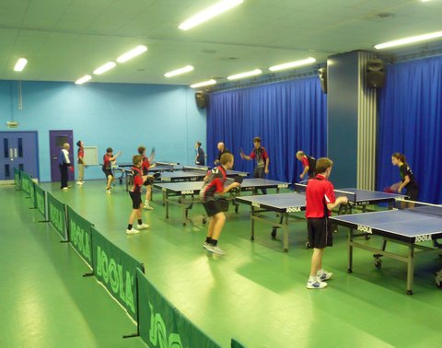

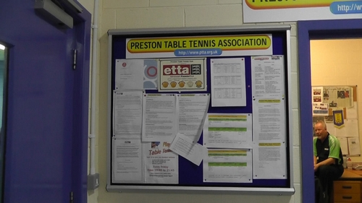

The purpose-built TT Centre was specifically designed as an integral part of the St Augustine’s New Avenham Centre, a £5M sports and education centre which itself was formally opened by the Duke of Kent.

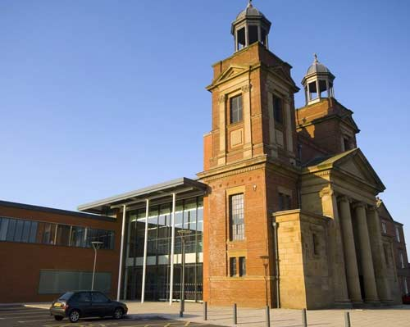

Funding from Sport England, Lancaster Diocese and other regional and European sources contributed to the development of the Centre which had been built on the site of the former St Augustine’s of Canterbury Catholic Church in Avenham, Preston. (*In fact the church’s facade with its four-column portico with pediment and its two towers with their cupolas was retained and can still be seen).*

In 2010, the ownership of the facility transferred to the nearby Cardinal Newman College who now manage the St Augustine’s Building as a combined educational and sporting facility, with support from the Preston City Council.

The Table Tennis centre itself is physically located at the rear of the building on the lower floor adjoining the main Sports Hall. It is used by the Association’s members every weekday evening, all year round, for either coaching, community sessions or winter/ summer league and cup competitions, and is occasionally used at weekends for special coaching activities or tournaments.

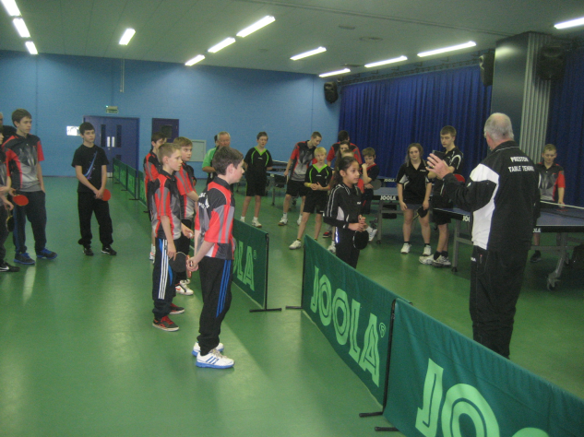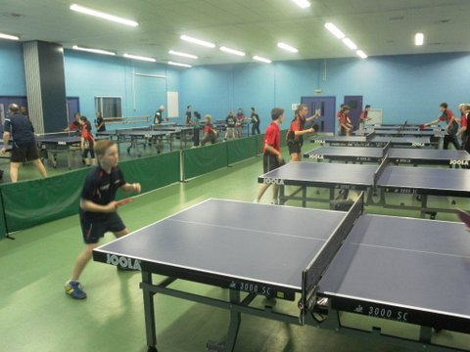

The TT Centre facilities are detailed below: -

|  |  |
| --- | --- |
| Capacity | 6 tournament tables at ETTA Grade 2 conditions. 10 tables for Junior Tournaments and 14 for coaching at ETTA Grade R conditions. |
| Tables | Joola 3000SC (14 off) with surrounds / umpires tables and score boards. (Wheelchair accessible tables are available) |
| Floor | Gerflor Vinyl Sports Flooring |
| Lighting | Fluorescent min 500 lux at 4m height for practice and league matches, 700 lux halogen for tournaments |
| Administration | Preston Table Tennis Association Office |
| Changing Rooms/ Toilets | Male and female with showers; facilities for people with disabilities |
| Equipment Storage | Two rooms adjoining the main hall |
| Reception Desk | Manned by Preston City Council staff |
| Health & Safety | Access to Telephone, First Aid Kit and Defibrillator. |
| Refreshments | Vending Machines available |
| Parking | Car parks to front and rear of Centre for approx 50 cars |

The adjoining Sports Hall facility, shown below, is also used by the Association for staging larger tournaments and events, including the annual Preston Closed Championships and the famous Preston Guild Table Tennis Tournament , which is only held once every 20 years. (NB. The next Guild Tournament is scheduled for 2032!)

The sports hall capacity is 10 tournament tables @ ETTA Grade 2 conditions.

European International TT matches between England and Portugal (Men) and England v France (Ladies) were actually staged in the Sports Hall in 2011.

