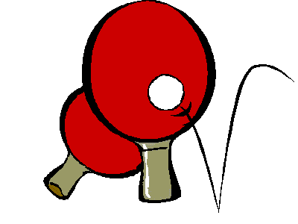
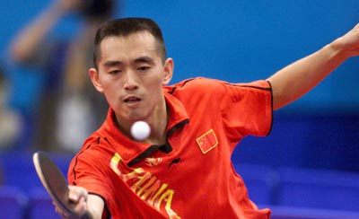
RHYL COMMUNITY TABLE TENNIS CLUB

WARM UP EXERCISES

BEFORE TRAINING

Jogging only for those capable of fast movement

- Jog around the hall, slowly for all (once around hall)
- Sidesteps facing in, once round hall, sidesteps facing out, same way once round hall, then two to the left and two to the right alternately all around the hall.
- Hands behind back, kick ups to hands, ½ way round hall
- Hands in front, level with elbows, knees up to hands (not hands to knees) ½ way round hall
- Two steps forward touch floor with right hand jump up to stretch to ceiling with left hand, two steps forward, touch floor with left hand jump up with right hand stretch to ceiling. All the way round hall.
- Swivels (as in football swivels) alternative feet, one behind the other. Once round hall
- Jog and relax!
- Turning backwards on tip toes, small steps jogging once round hall, then sprint one length of hall, small steps backwards to beginning, then repeat 3 x times

Relax and stretches necessary FOR ALL AGE OF PLAYERS

KNECK: - Head up to ceiling, head down to chest, five times each, slowly!!
Chin touch left shoulder, chin touch right shoulder, repeats 5 times each.
SHOULDERS:- Touch shoulder with fingertips, rotate elbows forwards 5 times, rotate elbows back 5 times.
Hold right elbow to chest with left wrist, press to stretch shoulder, hold left elbow to chest with right wrist, press to stretch left shoulder.
Right hand fingers as far down back as possible push elbow down the back to stretch, as far as you can without pain.
Left hand fingers as far down the back as possible push elbow down the back to stretch as far as you can without pain.
Hold out arms horizontal to the side, Large circles backwards reducing to small circles backwards faster, faster, faster until it hurts as much as you can bear for 15 seconds!! Repeat Forwards Large, then small circles.
WAIST:-
Hold elbows horizontal at shoulder level, turn to the left as far as you can, then turn to the right as far as you can repeat both 5 times.
Stetch right hand into the air then as far over to the left as possible, with left hand down the left side as far right as possible, Stetch left hand into the air then as far over to the right as possible, with the right hand down the right side as far right as possible,
Stretch both hands into the air, bend to touch the floor, three times, after the third time swing arms touching each toe first left then right, with opposite hand behind back in the air, hand swivels, toe touches!!
WRISTS
With both wrists and both elbows touching, rotate wrists 5 times to the left and 5 times to the right.
Floor, lay flat on back, hands to touch each side of your head only, the raise legs 6 inches off floor hold! Open legs slowly to the count of 4 then close legs to the count of 4, then lower down to floor, 1st time, repeat for twice without lowering legs, then repeat without dropping feet to the floor for three, four then five times, six or seven if possible. Maximum some students did was 25 times. Good for tummy strength!!
Laying on your back, touch floor behind your head, sit ups to touch toes, 10 times.
Over on front 10 press ups!! Finish with Bench jumps 10 each side over large bench.
Finish!! 10-15 mins Max

On the table exercises next!!

ON THE TABLE EXERCISES FOR ALL

General for all players

IMPORTANT ALL EXERCISES BE COMPETED WITH FEET WIDER THAN THE SHOULDERS APART AT ALL TIMES

- Forehand to forehand short topspin drives 5 minutes, for L/H players(L/H) forehand to backhand
- Backhand to backhand topspin drives 5 minutes, for L/H Players backhand to forehand
IMPORTANT this exercise is CONSISTENT TO ONE SPOT NOIT DOWN THE MIDDLE, and not to fast so that all players have a comfort zone TARGET 250 with 4 mistakes needs a coach, do not bend wrist
- For R/H players B/H to F/H, TARGET 250 with 4 mistakes needs a coach, do not bend wrist
- Take one small pace back and repeat 1 to 3 for heavier topspin drives (not yet loop drive)
- Take a further step back for loop drive same as steps 1-3

PLEASE REMEMBER WHEN COMPLETING THESE EXERCISES WHEN MOVING TO THE LEFT, LEFT FOOT FIRST, WHEN MOVING TO THE RIGHT, RIGHT FOOT FIRST

For the more experienced r/h player!!

- One b/h across the corner returned, then move to the left, one f/h after a skip and a step to the left!
- Repeat... several times. If players cannot move easily then play 4 or five b/h first, move, then 4 or 5 forehands before moving again, each time making sure the correct position is found on both f/h and b/h wings, before moving again!!

Many other combinations to come!! SEE COACH or training manuals!!!

Barrie Russ

