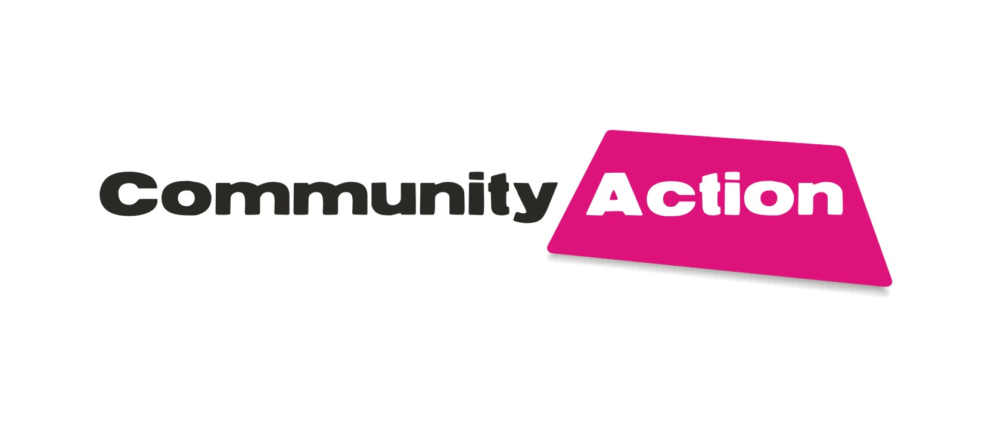


Sported

Sported is now offering services in Derbyshire and is inviting applications from community organisations that require support and funding. To help organisations with this Sported are delivering a workshop on 30th October 2012.

Who should attend?

Groups, clubs, organisations and social enterprises delivering Sports for Development projects, which use sport to have a positive community or social impact. Applicants must be engaging with young people aged 11-25 and working within disadvantaged communities.

What will be covered in the session

- What is Sport for Development
- The services that Sported offer to voluntary organisations
- Benefits of the member services

Date/Time Tuesday 30th October 2012
2.00pm – 4.30pm (registration at 2.15pm)

Venue Community Action
4 Charnwood Street
Derby DE1 2GT

Tutor Cheddi Gore (Regional Manager)

Cost Free

How to book to request a booking form either email training@communityactionderby.org.uk or contact Shaun Kennedy on 01332 227731

For further information visit www.sported.org.uk

