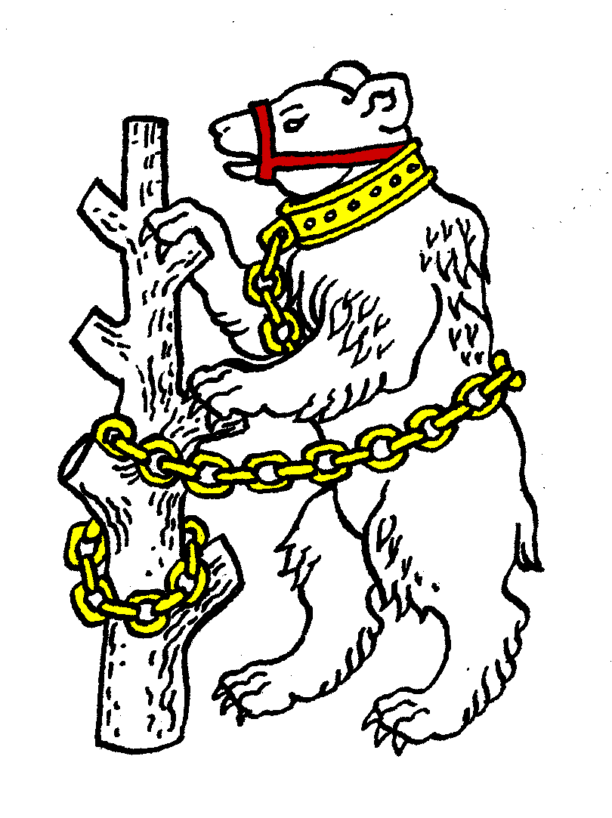
Warwickshire Table Tennis Association

1 Wilson Grove
Kenilworth
Warwickshire
CV8 2SL
carolineandestyn@gmail.com
01926 855729
26 June 2012
Dear Colleague
The Executive Committee will meet on Thursday 28 June 2012 at Kenilworth Wardens Club, Glasshouse Lane, Kenilworth, CV8 2AL, immediately after the Annual General Meeting.
I very much hope you will be able to attend.

Yours sincerely

Caroline Williams
General Secretary

Agenda
- Apologies
- Minutes of the previous meeting 10 May 2012
- Matters arising from the minutes of 10 May
- General Secretary’s report and correspondence
- Any other correspondence
- Financial report (if not all covered in AGM)
- Leagues report
- National Councillor’s report
- County Championships’ report, and entries for 2012/2013
- County Umpires’ report
- Coaching report
- Publicity report
- West Midland Regional Committee report
- Warwickshire Team championship report
- Schools report
- Webmaster report
- Arrangements for Talent Identification Day and Junior Trials
- Arrangements for production of Handbook for 2012/2013 season
- AOB
- Date of next meeting:-
Thursday 27 September 2012 7.45pm at Kenilworth Wardens Club

