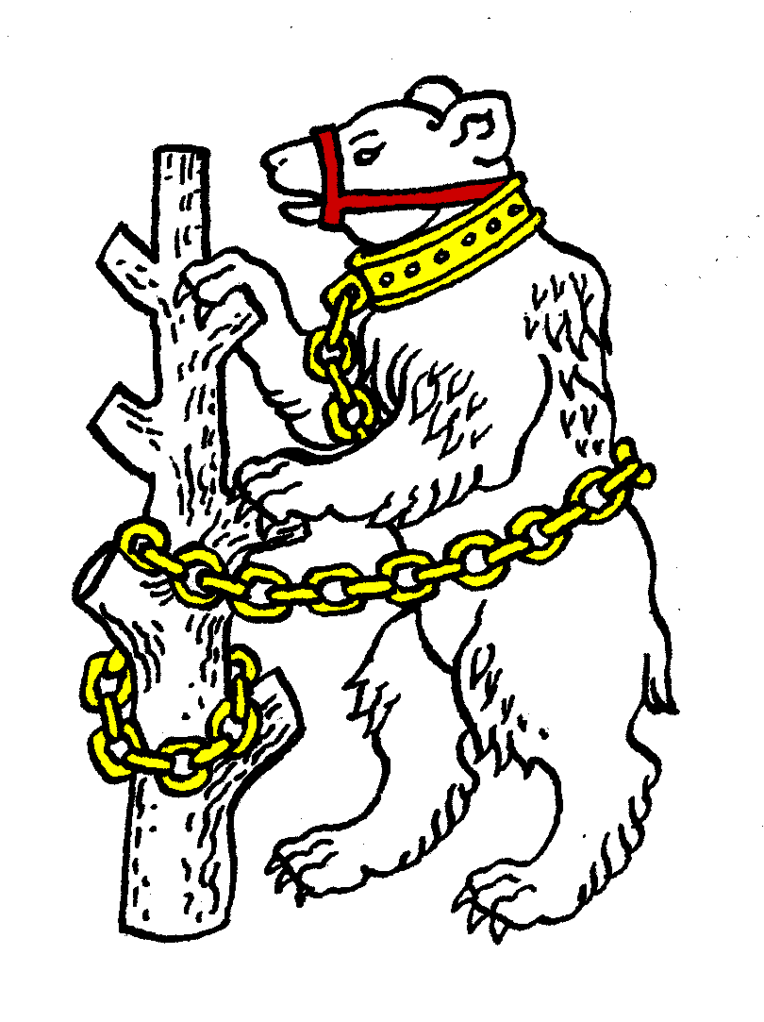
Warwickshire Table Tennis Association
Minutes of the Warwickshire Executive Committee Meeting held on Tuesday 21 May 2013, at Kenilworth Wardens Cricket Club
Members present
Estyn Williams, Caroline Williams, Tim Fell, Ian Ferguson, Inky Moss, Neil Wheatley, John Chandler, Malcolm Macfarlane.
- Apologies – Peter Morris, Jo Outhwaite, Phil Paine and Tracey Fletcher.

- Minutes of the previous meeting 19 March 2013
Item 11 c) amended to read that: Ian Ferguson is liaising with Tom Brocklehurst and Chris Mulligan to plan quarterly coaching sessions between Free Church and Colebridge at alternate venues.
The minutes were then approved and signed as a correct record.

- Matters arising from the previous meeting
Item 3 (Item 4): re Worcestershire rule – agreed to be discussed at September meeting in preparation for Warwickshire Closed in January 2014.
Item 6: IF was able to contact Dawn Sagoo during the meeting to arrange for the Wheelers Timber donation.
Item 15 (b): Senior B played but finished runners-up and so do not get promoted.

- General Secretary’s report and correspondence
ETTA Correspondence:
- County Championships entry form
- Regulation change propositions
- Election forms for National Councillor (see Items 9 and 10)
- County championships conference 1 June 2013, MM agreed to attend
- National Council 13 April 2013 – summary, chairman’s report plus 7 reports
- Election results for ETTA vice-chairmen for 2013/14
- Minutes of the 2012 ETTA AGM and EGM
It was agreed to vote for the County Championships Conference propositions as follows:
Proposition 2 (Bucks) to alter pooled expenses system: against
Proposition 3 re failure to send a team: for
Proposition 4 on altering player eligibility qualifications: against
Proposition 5 on registration: for
Proposition 6 amending numbering: appeared not significant, MM to check
Proposition 7 on match procedure to be amended: for
Proposition 8 on increasing fines: for
- Any other correspondence - none

- Financial report
See account sheets.
MM said that this year had been a spending year so accounts show a large deficit, though £200 still to pay in. IF contacted Dawn Sagoo re Wheelers Timbers donation (£400) who said that that would be paid shortly. Monies spent were used to kit out Senior A and Junior teams, sufficient for next few years.
MM reported that Adrian Pilgrim had submitted a bill for £100 for coaching cadets at an evening session before and during the County weekend. MM had had to pay this. However it was agreed that:
“In future no payment will be made for captaining county championship teams other than reasonable out of pocket expenses.”
Agreed to recommend to AGM:
“Fees for the 2013/14 season to remain the same as 2012/13.”

- League reports
Birmingham – last week the summer league started with 3 divisions of 6 teams. Had a successful presentation & MG Trophy night. B’ham Closed for 2012/13 is to be held on Sunday 15 September 2013
Coventry – CW to write to Coventry to suggest they appoint a rep to attend Warks meetings.
Leamington – 90+ attended presentation evening.
Several contentious motions for L’ton AGM, which the L’ton committee opposes:
- to restrict new teams joining with venues > 12 miles from LSpa
- principle that interclub matches should not be held last in the season
Also changes being made to the Headquarters building at Radford Semele
L’ton league website changing.
Nuneaton – none
Stratford – Shottery A won the league. Cup Final has been played with Shottery B winning against Royal Mail in the final.

- National Councillor’s report
Last meeting was on 13 April 2013, next one is in late July. April main topics were:
- Election of new Vice-Chairmen for 2013/14. All unopposed but have to be voted for.
- UK CC coaching license. Issue of coaches who have not yet done bridging course has been resolved. There is no need for them to do it, provided they have had CRB (now PBS) done and have First Aid certificates.

- Election of National Councillor 2013/14
Estyn Williams was re-elected 7-0, with 1 abstention

- Election of Deputy National Councillor 2013/14
Malcolm Macfarlane was re-elected 7-0, with 1 abstention

- County Championships
Cadets - won division so into Premier next season. Senior A also did well.
Senior B did fairly badly. Beat Gloucester but lost to Worcs.
Juniors were outclassed. Vet and Over 60 finished mid table.
Agreed that Kate Hughes be approached by MM to see if she would be willing to captain the Cadet team for 2013/14. MM to inform Adrian Pilgrim of this change.

- County Umpires
List of county umpires requested by Rob Sinclair (ETTA), but only really IM available now.
Suggested that clubs should be asked if anybody interested in becoming an umpire at league or county level. Suggestion of holding an “Umpires Day”.
Agreed that umpires needed for Senior A and Junior matches.
- Coaching report
- Parents have been contacted re girls training sessions
- Kate Hughes is contacting Helen Lower re a coaching workshop in West Mids/Warks.
- Colebridge / Free Church coaching still to be discussed.
- Clubs not yet contacted.

- West Midlands Regional Committee
- Chris Newton now on paternity leave.
- NW waiting for details on Ping for July 2013
- No details of development money. EW advised NW to contact Phil Goulding at ETTA.

- Schools report – no report
- Webmaster – no report

- Arrangements for AGM, including any proposed rule changes
No rule changes received. All present said that they would re-stand. NW agreed to stand as Vice Chairman (currently vacant).
Edward Lynn suggested as “clubs” – CW to contact

- Arrangements for Talent Identification Day and Junior Trials
MM agreed to contact JO

- AOB
- Suggested that Warks Closed could be altered to have a separate Finals night, possibly at “The Ivy League” near the airport. JC offered to find out if available / suitable.
- Committee meeting after the AGM to be short with a short agenda.

- Date of next meeting
Tuesday 27 June 2013 AGM, 7.45pm at Kenilworth Wardens Club, followed by a short committee meeting.

The meeting closed at pm

