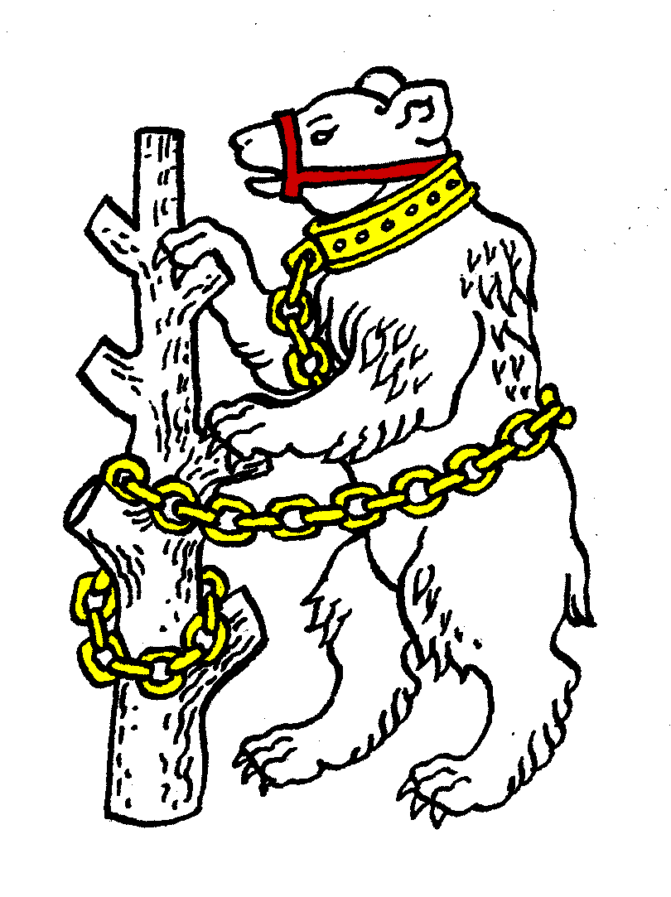
Warwickshire Table Tennis Association
Minutes of the Warwickshire Executive Committee Meeting held on Thursday 27 June 2013, at Kenilworth Wardens Cricket Club
Members present
Estyn Williams, Caroline Williams, Malcolm Macfarlane, Tim Fell, Peter Morris, Jo Outhwaite, Inky Moss, Kate Hughes, Richard Grover, Neil Wheatley, Barbara and Bob Hughes (representing Birmingham).

- Apologies – Phil Paine, John Chandler.

- Minutes of the previous meeting 21 May 2013
The minutes were approved and signed as a correct record.

- Matters arising from the previous meeting
- Item 11: KH has agreed to be Cadet team captain & Adrian Pilgrim has been advised.
- Item 7: At Leamington AGM motion to restrict teams in league to 12 miles radius was defeated.
- Item 13b: KH reported re coaching workshop. If we wanted one Helen Lower will come to Colebridge so KH has given HL potential dates.
- Item 14b: There will be Ping in Birmingham but NW does not know who is organising it or dates.

- General Secretary’s report and correspondence
ETTA Correspondence:
- Notice of ETTA AGM on 13 July. Membership year to amend to run August to July. Leamington amendment re payment of fees likely to be accepted.
- Sports Liability Insurance
- 2013/14 directory form for completion.
- Any other correspondence none

- Arrangements for Talent Identification Day and Junior Trials
Cadets will be playing in January at a Premier weekend. Juniors are not due to play until 2 November. KH, Ian Ferguson & JO will organise dates for TID/Trials. MM will then email all Juniors plus General Secretaries.

- Arrangements for production of Handbook for 2013/14 season
EW to circulate drafts so that addresses can be checked. Calendar to be completed. To be printed by MM in late August for circulation to league players.

- AOB
- KH reported that county cadet training to be held at Colebridge, girls & boys, max 10, including potential players, possibly one in summer, one in October.
- NW: Heart of England league – last one this year unless new organiser is found, as Brian Aston and Eric Teale are retiring from running it.
- PM: good news from Nuneaton who had 120 attending annual presentation evening & casino night, Edward Lynn did presentations. Unfortunately current 23 teams may be reducing to 19.
- KH: Carter Cup (Juniors) Leamington came 2nd; Rosebowl (women) Leamington 3rd; Wilmott (Men) Birmingham won.
Next season hope to enter Bromfield (girls) as well.
- Adrian Pilgrim is playing in England Vets.

- Date of next meeting – Thursday 17 September 2013 7.45pm at Kenilworth Wardens Club.

Meeting closed at 9.55pm

