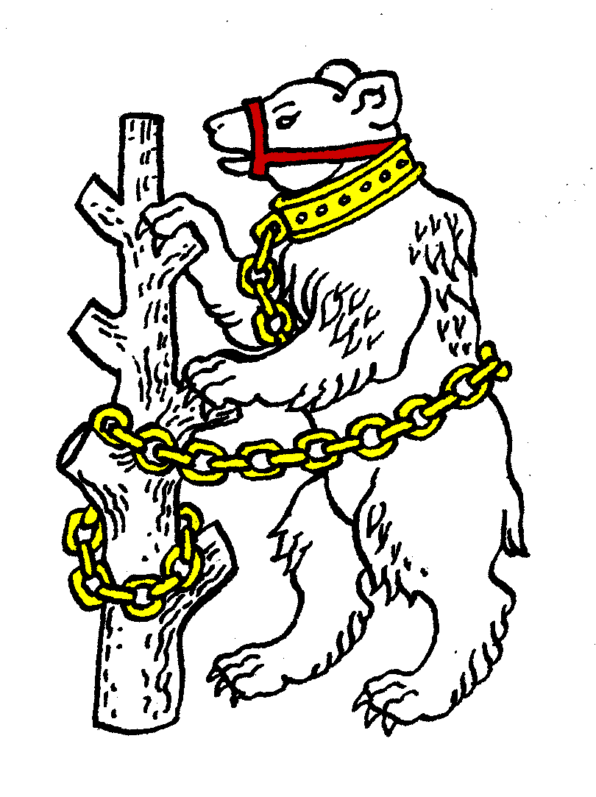
Warwickshire Table Tennis Association

1 Wilson Grove
Kenilworth
Warwickshire
CV8 2SL
carolineandestyn@gmail.com
01926 855729
23 January 2013
Dear Colleague
The Executive Committee will meet at 7.45pm on Thursday 24 January 2013 at Kenilworth Wardens Club, Glasshouse Lane, Kenilworth, CV8 2AL.

Directions to Kenilworth Wardens – Entering Kenilworth from the south (e.g. from Leamington) go over the A46 Kenilworth bypass roundabout. At the next roundabout (St John’s) turn right into Birches Lane. Drive straight along this road for about a mile (partway it changes into Glasshouse Lane) when Kenilworth Wardens is on the right at the point where the street lighting ends, just after the Dencer Drive left turning. It has a large yellow signboard outside. Drive into the car park, enter the building through the main doors facing the cricket pitch and walk into the bar. The meeting will be held in the room to the right of the bar.
I very much hope you will be able to attend.

Yours sincerely

Caroline Williams
General Secretary

Agenda
- Apologies
- Minutes of the previous meeting 22 November 2012
- Matters arising from the minutes of 22 November 2012
- Results of Warwickshire Closed 6 January 2013
- General Secretary’s report and correspondence
- Any other correspondence
- Financial report
- Leagues report
- National Councillor’s report
- County Championships’ report
- County Umpires’ report
- Coaching report
- West Midland Regional Committee report
- Schools report
- Webmaster report
- AOB
- Date of next meeting:-
Thursday 24 March 2013 7.45pm at Kenilworth Wardens Club

