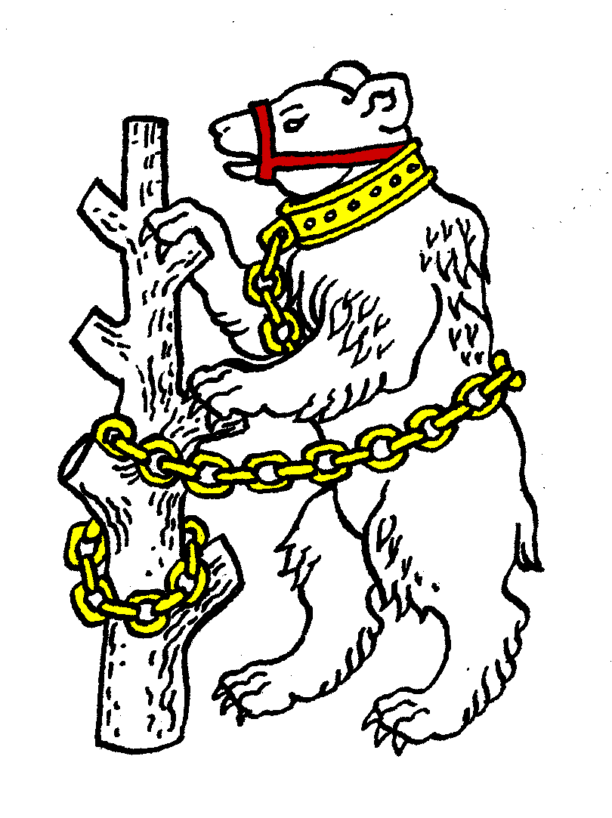
Warwickshire Table Tennis Association
Minutes of the Warwickshire Executive Committee Meeting held on Thursday 24 January 2013, at Kenilworth Wardens Cricket Club
Members present
Estyn Williams, Caroline Williams, Richard Grover, Tim Fell, Ian Ferguson, Malcolm Macfarlane and John Chandler.

- Apologies – Jo Outhwaite, Peter Morris, Neil Wheatley, Phil Paine, Inky Moss.

- Minutes of the previous meeting 22 November 2012
The minutes were approved and signed as a correct record.

- Matters arising from the previous meeting
Item 19: Spotlight system will be staying after all

- Results of the Warwickshire Closed 6 January 2013
Results are on website. There were problems with the new results sheets used as well as various other problems. PayPal entries collected £1030, plus a further £600 by cheque or cash by post or on the day. PayPal costs 3% plus £22. However Closed made a profit of £890.17, to be split between Leamington and Warwickshire, half to each.
MM requested that the Committee reconsider the rule concerning eligibility for the Warwickshire Closed decided on 27 September 2012 as it had caused some problems. It was agreed that this should be looked at again and in particular to compare with Worcestershire’s rule on this subject.

- General Secretary’s report and correspondence
ETTA Correspondence:
- Funding for ETTA.
- 2012/13 directory.
- List of approved 40mm balls
- List of approved Racket coverings

- Any other correspondence - none

- Financial report
See sheet. Shirts now obtained costing £500. Senior shirts will be labelled Peter Morris accountants. Member subs income reduced by £100 as number of teams gone down in Birmingham.
MM proposed to change to internet banking. Agreed.

- League reports
Birmingham – Closed had to be postponed for snow.
Stratford – struggling really as insufficient players.

- National Councillor’s report
Next Meeting this Saturday 26 January 2013. Coming up is:
- Proposal to increase membership fees by £2.
- Sport England grant.
- ETTA chairman election
Proposed that County vote should be for Andy Seward as Chairman, plus his running mates for Deputy and Treasurer. Agreed

- County Championships
Junior: second weekend players have been picked.
Seniors: selected.
It was agreed that next season selection should be done where possible after Warks Closed, to make it easier to do.
Over 60: 10/11/February at Draycote

- County Umpires – no report

- Coaching report
Girls training session booked, to be held at Rugby, but had to be cancelled because of the snow last weekend. 11 were going to attend. Will try to rearrange.

- West Midlands Regional Committee – no report

- Schools report
JO emailed to say that the Warwickshire Schools competition and the next round of the Schools team competition was snowed off last weekend
The Schools competition U11, U13 and all girls is re-scheduled for 8th February.

- Webmaster
RG reported that Colebridge had been having problems with comments put on social media.

- AOB
There was a request to hold these meetings on a different date to see if that helped. It was agreed to hold the next meeting on a Tuesday.

- Date of next meeting
Tuesday 19 March 2013, 7.45pm at Kenilworth Wardens Club.

