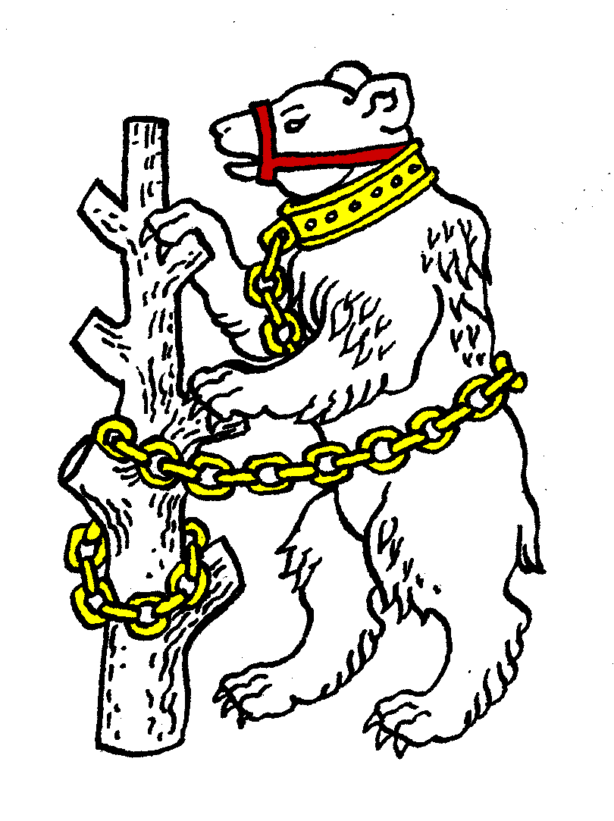
Warwickshire Table Tennis Association

Minutes of the 2013 Annual General Meeting - draft

This was held at Kenilworth Wardens Cricket Club, Kenilworth, on Thursday 27 June 2013 at 7.45pm

Members present
Estyn Williams, Caroline Williams, Richard Grover, Malcolm Macfarlane, Tim Fell, Dorothy Macfarlane, Neil Wheatley, Peter Morris, Jo Outhwaite, Inky Moss, Kate Hughes, Bob and Barbara Hughes.

- Apologies
Phil Paine, John Chandler,

- Minutes of the previous AGM meeting 28 June 2012
Item 14: amend Mr David Taylor to read Mr David Palmer.
The minutes were approved and signed as a true record, with this amendment.

- Matters arising from the AGM minutes
Item 3: CW reported that she had contacted Edward Lynn, but that he had not replied yet.
Item 4: The eligibility qualification had been tightened up for the 2012/13 Closed, but this had not been completely satisfactory. It was agreed that this would be looked at again in September prior to the 2013/14 Closed.

- Report from the Executive Committee:
County Chairman’s report
EW reported that there would be a new Chairman and Board after the ETTA AGM in July. He like many others had felt that the old Chairman Alex Murdoch after 10 years had run out of ideas. Biggest issue is ETTA’s finances with > 85% coming from government grants, based on high public participation. Currently ETTA have a one year’s grant as Sport England want to check up on how ETTA work and are using consultants (Portas) to report on ETTA. Further grants will depend on the Portas report.
Also Richard Yule, Chief Executive of ETTA for many years retired on 31 May 2013 and will be replaced initially by an interim Chief Executive.
County Team’s report
See separate sheet.
Cadets – won Division 1B and so will be in Premier for next season.
Juniors – finished bottom of Premier so will drop now to Division 1.
Seniors A – second in Division 1A;
Seniors B – second in Division 2B.
Veterans – finished 6th from 8
Over 60 – finished top of the bottom 4 - 5th from 9 in a division with 4 very strong teams finishing above us.

Tournament report
A long day with an entry of 120. Discussion took place on how to improve timekeeping including playing doubles early and / or moving to holding a finals night for the 10 major events. Consensus was not to have a finals night.
School Secretary’s report
Another busy year hampered by snow and re-scheduling problems.
Under 19 team event: Lawrence Sherriff reached finals (8 teams left in) finishing with a silver medal after losing out 14/15 on countback to Caldeck Grange Grammar (West Kirby). AGM congratulated LS on result.
Individual event: 56 entries from 24 schools including 7 Under 11 girls meant that Warks were represented at National level in every age group.
AGM wished to give their thanks to JO and others who helped her.
Umpire secretary’s report
Now only IM left to do umpiring as Dot Macfarlane is more involved in the admin side, so agreed that we need to encourage people to take umpires course.
Agreed that an umpires course should be held in the area, which WTTA would help with costs, appropriate level of course to be considered.
Agreed that it was particularly difficult when other teams failed to provide umpires for County Championship matches.
Competition secretary’s report
NW only had one entry for the Warwickshire team Championship last season so not held. Agreed to be held in April or May 2014, NW to book suitable date.

- County Treasurer’s report
See separate sheet.
MM reported that there had been a big expense on shirts this season so there was a high excess, partly because the £500 sponsorship for the shirts had been received in the previous financial year.
MM recommended no change in membership fees, which was agreed.
The AGM thanked the Treasurer for his good work, and approved the accounts.

- Rule Change propositions – there were no motions

- Motions - There were no motions.

- Election of President
Phil Paine was re-elected as President unopposed.

- Election of Chairman
In the absence of the President, the Treasurer Malcolm Macfarlane took the Chair for the election of the chairman. Estyn Williams was elected as Chairman unopposed.

- Election of other Officers
The following officers were elected unopposed:
- Vice Chairman – Neil Wheatley
- General Secretary – Caroline Williams
- Treasurer – Malcolm Macfarlane
- County Match Secretary – Malcolm Macfarlane
- Publicity Secretary – Caroline Williams
- Competition Secretary – Neil Wheatley
- Umpires Secretary – Inky Moss
- Coaching Secretary – Ian Ferguson
- Webmaster – Richard Grover

- Election of representatives of WTTA at the West Midlands Regional Committee of ETTA
Neil Wheatley and Malcolm Macfarlane were elected unopposed, though as they are WMRC Chairman and Treasurer respectively they are automatically on WMRC.
Richard Grover was also elected unopposed and two vacancies were left vacant.

- Election of one person to represent schools table tennis
Jo Outhwaite was elected unopposed.

- Election of one person to represent clubs table tennis
Edward Lynn to be contacted again.

- Election of Life Members
Mrs Veronica Jackson, Mrs Thalia Whitehead, Mr Geoff Taylor, Mr David Palmer and Mr Bob Montgomery were confirmed to continue. All five names are to be listed on the front page of WTTA Handbook.

- Election of Auditor for 2013/14
Bob Hughes was elected unopposed.
The AGM gave thanks to Bob for doing the accounts.

- AOB
- Development: NW said that ETTA is directing Chris Newton to concentrate on the “local hotspot” (Birmingham) as a priority, but NW considers that he (NW) is available to help areas outside Birmingham.
- Ping Birmingham to start shortly for third year. Unfortunately new Ping projects are this year only for big cities so Solihull has not been chosen.

- Date of next WTTA AGM
AGM – Tuesday 24 June 2014 7.45pm at Kenilworth Wardens Club.

