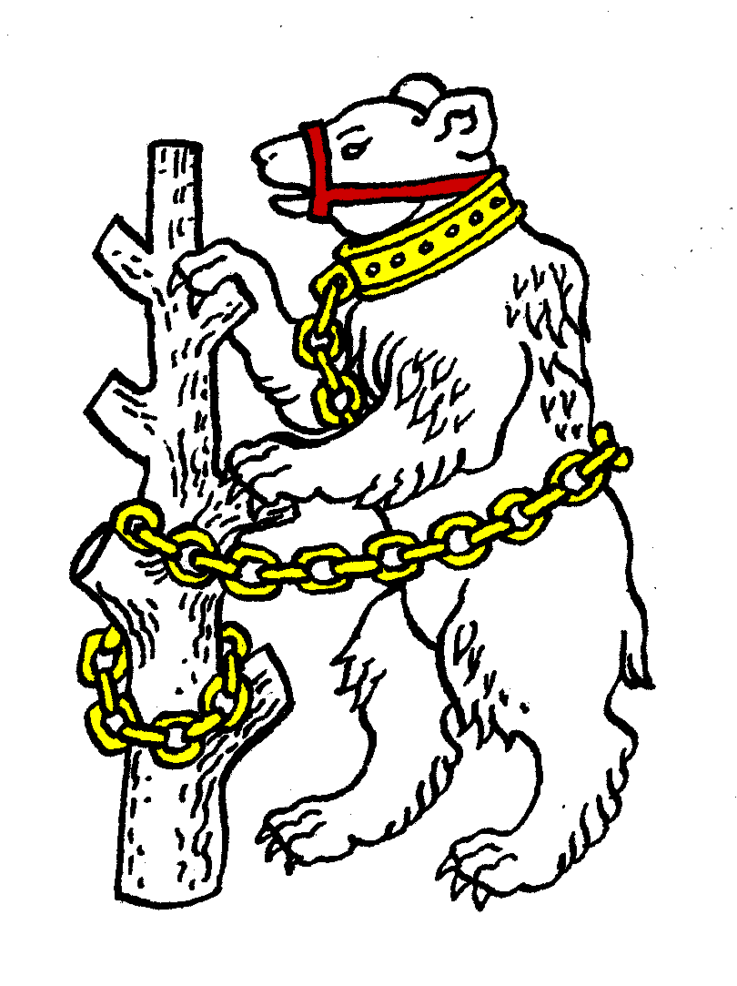
Warwickshire Table Tennis Association
Minutes of the Warwickshire Executive Committee Meeting held on Thursday 27 September 2012, at Kenilworth Wardens Cricket Club
Members present
Estyn Williams, Caroline Williams, Richard Grover, Tim Fell, Peter Morris and John Chandler.

- Apologies – Malcolm Macfarlane, Inky Moss, Neil Wheatley, Phil Paine, Jo Outhwaite, Adrian Pilgrim.

- Minutes of the previous meeting 28 June 2012
The minutes were approved and signed as a correct record.

- Matters arising from the previous meeting
See items 5 and 19 below.

- Matters arising from the 2012 AGM
It was regretted that there was still a vacancy for the post of Vice-Chairman

- Arrangements for the Warwickshire Trials and Talent Identification Day
Date amended since last meeting to 13/14 October. JO had emailed CW with new details. As it was uncertain what publicity had been posted, CW agreed to email details to league secretaries, executive committee plus those on Leamington League’s lists.

- General Secretary’s report and correspondence
ETTA Correspondence:
- 2012/13 directory form received for completion, was returned in August as requested.
- 2012/13 form to detail local leagues affiliated to Warwickshire has been received, to be returned in December.
- Alan White disciplinary
- National Council minutes and reports from 21 July 2012 meeting

- Any other correspondence
EW had received a letter from ETTA re the Midland League. EW to advise ETTA that Midland League do not wish to affiliate.

- Financial report
MM had emailed that expenditure was as follows: AGM food £20, Handbook costs £120, schools Affiliation £45. Income nil. League fees forms to be sent out next week.

- League reports
Birmingham – summer league had finished. Autumn league to start next week with 4 divs of 9, 2 of 8, which is 2 teams less than last season.
Coventry no info.
Leamington – League started Monday 24 September, with 42 three aside teams, 23 two aside, ie 65 in total which is slightly less than last year. Still get new people contacting us.
Nuneaton – starts next week, 23 teams from 6 clubs, though only 1 club has juniors and 2 teams play in the upstairs room of a pub!
Stratford – 1div of 9 teams, no change from last season. 2 players in twenties but rest are over 50. Starts 8 October 2012.

- National Councillor’s report
Meeting 22 July 2012 and first since AGM. President Keith Ponting has died so will need to be replaced. Discussion on funding, as at ETTA AGM the increase in subs had been voted down. 85% of ETTA funding comes from the government (Sport England) and is awarded at basic or elite levels. Basic refers to how many play the sport, based on the national survey done recently on who plays each month and includes non-ETTA players. Elite funding is based on the chance of winning Olympic medals. We do well at basic.

- County Championships
MM reported that matches had been organised as follows:
Cadet: 2 matches Phoenix 8 December, 4 Matches at BATTS 16 March
Junior: Cippenham 10/11 November, Wood Green 2/3 February
Senior A: Halifax 16/17 March
Senior B: Rugby 23/24 March (Proposed)
Vets A: St. Neots 27/28 October, Halifax 24/25 November
Over 60’s: 2 matches Halifax 10 November, Draycott 9/10 February, 1 match at Colebridge to be arranged v Worcs.

- County Umpires – none.
- Coaching report - none
- Publicity report – no report
- West Midlands Regional Committee - none
- Warwickshire Team Championship
Believed that it had not been possible to hold it this month.
- Schools report – no report
- Webmaster
RG requested that items be passed to him to be put on website, including handbook.

- Arrangements for Warwickshire Closed Sunday 6 January 2013
Incorrectly shown on agenda as December.
Need loudspeaker to use.
It was agreed to add a rule so that players playing for counties outside Warwickshire should not be eligible to enter the Closed Championship.
“Eligibility will be as at present except that anyone who has played for another County last season or this season is ineligible to enter unless they are now playing for Warwickshire.”

- AOB
New Deputy for Birmingham is Steve Smith.

- Date of next meeting
Thursday 22 November 2012, 7.45pm at Kenilworth Wardens Club.

