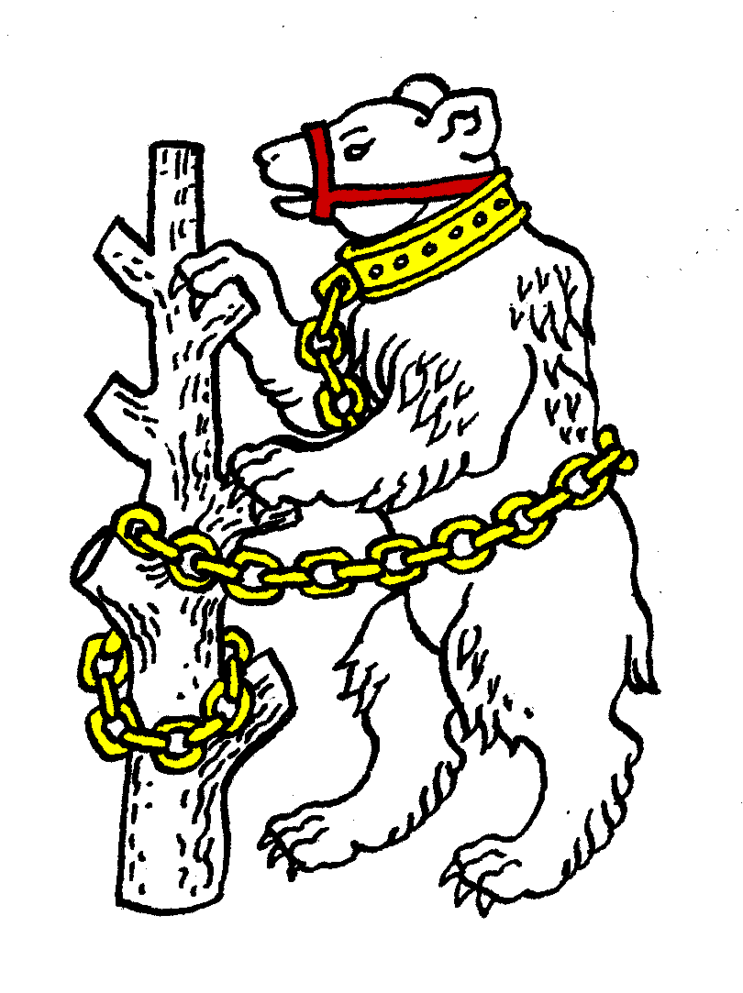
Warwickshire Table Tennis Association Rules

1. NAME
The Association shall be called Warwickshire Table Tennis Association.

2. OBJECTS
2.1. The Association shall be affiliated to the English Table Tennis Association Ltd.
2.2. The objects of the Association shall be as follows:
2.2.1. To act as the controlling and governing body for the sport of Table Tennis in the County of Warwickshire subject to any overriding decisions of the National Council of the English Table Tennis Association Ltd.
2.2.2. To assist and encourage the formation of Table Tennis leagues and clubs in the County of Warwickshire and to promote the sport in every possible way.

3. AREA OF JURISDICTION
The area of jurisdiction of the Association shall be the County of Warwickshire as defined by the Rules of the ETTA. (The area coincides with the areas of Birmingham City Council, Coventry City Council, Solihull Metropolitan Borough Council and Warwickshire County Council.)

4. DEFINITIONS
In these Rules and any Regulations made hereunder:-
4.1. The following words and phrases shall have the meaning assigned by this Rule:
4.1.1. The Association: the Warwickshire Table Tennis Association
4.1.2. Casual Vacancy: A vacancy which occurs at a time when the normal procedure prescribed by the Rules for filling it cannot operate.
4.1.3. ETTA: the English Table Tennis Association Ltd
4.1.4. Member: Any person mentioned in Rule 5.1, or any official, player or other individual member of a body mentioned in Rule 5.1.2 or of a club in membership of or affiliated to such a body.
4.1.5. National Council: the National Council of the ETTA.
4.2. Words and phrases defined by the Rules of the ETTA and not otherwise defined by these Rules shall have the meaning assigned to them by the Rules of the ETTA.

5. CONSTITUTION
5.1. The Association shall consist of:
5.1.1. The Officers
5.1.2. All Local Leagues, Directly Affiliated Clubs and Directly Affiliated Individuals affiliated to the ETTA which are within the jurisdiction of the Association as prescribed by the National Council (except those exempted by decision of the National Council)
5.1.3 Life Members
5.2. The Association shall without payment of fee accept into Good Standing the following, but no other, bodies:
5.2.1 All organisations within the jurisdiction of the Association which are in Good Standing with the ETTA.
5.2.2 All County or Regional Associations or organisations covering the area or part of the area of jurisdiction of this Association which are part of or affiliated to national Associations or organisations in Good Standing with the ETTA.
5.2.3 The County Schools Table Tennis Associations and Schools Leagues and School Clubs within the jurisdiction of the Association except such as are affiliated.

6. AFFILIATION
6.1. Affiliation to the Association shall be compulsory for all Local Leagues, Directly Affiliated Clubs and Directly Affiliated Individuals in the County, unless exempted by a decision of the National Council.
6.2. Application: Every applicant on behalf of himself or of a league or club shall complete and sign the current affiliation form.
6.3. A club or individual not directly affiliated to the ETTA may apply to be directly affiliated to the Association provided that it or he/she is affiliated to the ETTA through another body.
6.4. Every Local League and Directly Affiliated Club shall send to the General Secretary of the Association not later than 1 November each season a copy of its current Rules.
6.5. No person or body may affiliate to the Association unless affiliated to the ETTA.

7. AFFILIATION FEES
7.1 The Affiliation Fees payable by each Local League each season shall be the standard team fee multiplied by the size factor. The standard team fee shall be fixed from time to time by the Annual or a Special General Meeting. The size factor for a local league shall be the number of three aside teams, plus 0.75 times the number of two aside teams, plus 1.25 times the number of four aside teams. An ‘x aside’ team means that x is the lowest number of players required by the rules to constitute a full team in the division concerned.
7.2 The Affiliation Fees payable by each Directly Affiliated Club each season shall be the standard team fee times 1.75.
7.3 Affiliation Fees shall be paid on or before 31 October each season to the Association Treasurer.

8. OFFICERS AND NATIONAL COUNCILLOR
8.1. The Officers of the Association shall be: President, Chairman, Vice Chairman, General Secretary, Treasurer, County Match Secretary, Publicity Secretary, Competition Secretary, Umpires Secretary, Coaching Secretary and Webmaster.
8.2. Election: The Officers shall be elected by the Annual General Meeting and shall serve from the end of the meeting at which they are elected until the end of the Annual General Meeting following; they shall be eligible for re-election.
8.3 Casual Vacancy: Any casual vacancy may be filled by the Executive Committee.
8.4. National Councillor
8.4.1. Between 1 May and 15 June each Administrative Year the Executive Committee shall elect a National Councillor and may elect a Deputy National Councillor to represent the County for the following Administrative Year, after considering all nominations submitted to them by Members of the Association.
8.4.2. The General Secretary shall send a copy of the Executive Committee Minute recording the election or the information required by the ETTA official appointment form certified by himself and by a second person who must be the Chairman, Vice-Chairman or Treasurer to reach the ETTA General Secretary, or such other person as may be designated for the purpose by the ETTA Management Committee, by 20 June.

9. MANAGEMENT
9.1. The affairs of the Association shall be managed, subject to the control of the Annual General Meeting, by an Executive Committee consisting of:
(1) The Officers
(2) The National Councillor and the Deputy National Councillor
(3) One representative elected by each Local League. Each Local League may also appoint a deputy representative who shall be entitled to attend and vote at an Executive Committee meeting in the absence of the representative.
(4) Those persons the Association elects to represent it at the West Midlands Regional Committee of ETTA.
(5) One person elected by the AGM to represent schools table tennis.
(6) One person elected by the AGM to represent clubs.
9.2. Co-option: The Executive Committee shall have power to co-opt not more than two other members of the Association. Co-opted members shall have the right to vote.
9.3. Casual Vacancies: The Executive Committee shall have power to fill a Casual Vacancy in any Office or on the Executive Committee until the next Annual General Meeting.
9.4 Meetings: The Executive Committee shall meet as and when it decides or as decided by the Chairman and General Secretary provided that there shall be at least four meetings a year.
9.5 At least seven days notice in writing of the place, date and time of every meeting shall be sent to every member of the Executive Committee.
9.6 Quorum: The business of the Executive Committee may be transacted by not less than five members.
9.7 Chair: In the absence of both Chairman and Vice Chairman the Executive Committee shall elect one of its number to take the chair for the meeting.
9.8 Voting: Every question at a meeting of the Executive Committee shall be determined by a majority of the members present and voting, every member having one vote. In the case of an equality of votes the chairman of the meeting shall have a second or casting vote.
9.9 Regulations: The Executive Committee shall have power to make Regulations to cover such matters not specifically dealt with in these Rules as it thinks fit.
9.10. Standing Sub Committees: At its first meeting following the Annual General Meeting the Executive Committee shall appoint Standing Sub Committees to deal with the following matters:
(1) Umpiring (meetings of this sub-committee shall be convened by the Umpires Secretary)
(2) Discipline
(3) Selection
(4) Coaching
9.11. Sub Committees: The Executive Committee may delegate any of its duties and powers to sub committees consisting of such persons as it shall decide, provided that at least two members shall be members of the Executive Committee. Any sub committee shall, in the performance of its duties, conform to the Terms of Reference laid down by the Executive Committee. Unless decided otherwise by the Executive Committee, the chairman of a sub committee shall be responsible for reporting to the Executive Committee.

10. ANNUAL GENERAL MEETING
10.1. Date: Each season the Association shall hold an Annual General Meeting not later than 31 July.
10.2. Notice: To call the AGM the General Secretary shall give at least 35 days preliminary notice in writing of the place, date and time to the Officers and to the General Secretary of each Local League and Directly Affiliated Club. The preliminary notice shall:
(1) State that rule change propositions must be received by the General Secretary in writing at least 21 days before the meeting.
(2) State that motions must be received by the General Secretary in writing at least 21 days before the meeting.
(3) State the positions to be filled at the AGM, the names of those presently holding such positions and whether they are nominated for re-election and the names of any other persons already nominated.
(4) State that any further nominations must be received by the General Secretary in writing at least 21 days before the meeting.
10.3. Accredited Representative: Each Local League shall appoint one Accredited Representative to attend each General Meeting. Only the Accredited Representative shall be entitled to cast his league’s votes.
10.4 Right to attend: Attendance at the meeting shall be open to all Members.
10.5 Agenda:
10.5.1. The General Secretary shall circulate an agenda to those listed in rule 10.2 at least 14 days before the AGM. The following items shall be included in the agenda:
(1) Minutes of the previous AGM
(2) Minutes of any SGM held since the previous AGM
(3) Annual Report of Executive Committee
(4) Statement of Accounts
(5) The wording of any Rule Change Propositions (in accordance with rule 20.3)
(6) The wording of any motions of which the General Secretary has received notice in writing not later than 21 days before the meeting
(7) Election of Life Members
(8) Election of Officers
(9) Election of Executive Committee Members
(10) Appointment of Auditor.
10.5.2 Motions not included in the agenda shall not be voted upon except with permission of the chairman.
10.6. Voting. In any vote the vote allocation shall be as follows:-
10.6.1 The Officers of the Association shall each have one vote.
10.6.2 Local leagues shall have one vote for each 24 teams or part thereof in their league.
10.7. Special Majority: No resolution altering the Rules of the Association shall be declared carried unless at least two thirds of the total votes cast are in favour of that resolution.

11. SPECIAL GENERAL MEETING
11.1. A Special General Meeting shall be convened on a resolution of the Executive Committee or to take place within 28 days after receipt by the General Secretary of a requisition signed by two local leagues stating the business to be transacted at the meeting.
11.2 Rule 10 (except sub rules 10.1 and 10.5) shall apply.
11.3 A Special General Meeting shall transact only such business as is specified in the resolution or requisition convening it.

12. FINANCE
12.1. Bank Account: The funds of the Association shall be kept at a Bank or invested in a Building Society or other security approved by the Association.
12.2. Cheque Signatories: All cheques etc, drawn on the Bank, Building Society and other accounts shall be signed by any two of the following Treasurer, Chairman, Vice Chairman, and General Secretary.
12.3 The Financial Year of the Association shall end on 31 May.
12.4 Auditor: The accounts of the Association shall be audited each season by an independent auditor appointed by the AGM.
12.5 All income and property of the Association from whatever source derived shall be applied solely to the promotion of the objects of the Association.

13. DISSOLUTION
In the event of the winding up or dissolution of the Association, any surplus assets remaining after discharge of liabilities shall automatically vest in the ETTA who shall hold them for a period of six years in trust to pay them to any organisation set up with objects identical with or similar to those of the Association (the ETTA during such period making every endeavour to promote and encourage the formation of such an organisation) and thereafter for the general purposes of the ETTA.

14. APPEALS AGAINST LEAGUES
14.1 Any Member or affiliated club aggrieved by a decision or action of a Local League, or a Committee, Officer or official of such league, or by neglect or refusal to do something which such organisation or person is under a duty to do, may appeal against such decision, action neglect or refusal to this Association whose proper decision shall be final and binding on all parties.
14.2 The Association shall not have power to reverse a decision or action which is in accordance with the rules of the Local League unless it constitutes a breach of the Rules or Regulations of this Association or of the ETTA or of the principles of natural justice.
14.3 Any such appeal shall be made in writing to the General Secretary within 21 days after notification of the decision or action appealed against, and shall be accompanied by a fee of the amount prescribed by the ETTA and specified in the Schedule to this rule. The fee shall be returned if the adjudicating body consider the making of an appeal to have been justified (whatever the result).
14.4 Either party to the Appeal shall be entitled to require a Hearing before the adjudicating body.
14.5 Any party may be represented at a Hearing provided that the Association is notified in advance in writing of the intention to be represented.

15. DISCIPLINARY
15.1 A Member shall not do or cause to be done anything deliberately harmful to the Association nor likely to bring the Association or the sport of Table Tennis into disrepute.
15.2 A Member shall not without good and sufficient cause:
15.2.1. absent himself from the Hearing of any allegation or appeal after having been requested with reasonable notice to attend
15.2.2. refuse or neglect to answer any question put to him in connection with such allegation or appeal if directed to answer by the chairman of the adjudicating body

16. SUSPENSION
16.1 For a breach of this Association’s Rules or Regulations the Association shall have power to suspend any Local League, club, player or official within its jurisdiction, under the power created by ETTA Rules and subject to the right of appeal provided by such Rules.
16.2 The ETTA General Secretary shall be notified of any suspension under this Rule.
16.3 Such suspension shall be enforced by all bodies in this county, but shall operate only within the jurisdiction of this Association, the suspended person or body being deprived of the privileges of membership of or affiliation to this Association and any Local League or Directly Affiliated Club affiliated to this Association, but not of the privileges of membership of or affiliation to the ETTA enjoyed outside the jurisdiction of this Association.

17. DISCIPLINARY COMMITTEE
17.1 The Standing Sub Committee referred to in Rule 9.10 (2) shall be called the Disciplinary Committee and shall consist of at least five persons, one of whom shall be designated as Chairman by the Executive Committee.
17.2 Members of the Disciplinary Committee shall (unless they resign) serve until the end of the season in which they are appointed and thereafter until the appointment of their successors. Casual vacancies shall be filled by the Council/Committee.
17.3 A decision may be taken by not less than three members, all of whom must have been present throughout the hearing.
17.4 Any member of the Committee having an interest in a matter to be discussed must declare that interest as soon as he is aware of it, and must not be present in his capacity as a member of the Disciplinary Committee during the transaction of that business.
17.5 Should disqualification under Rule 17.4 leave less than three members as required by Rule 17.3, the Executive Committee shall appoint sufficient temporary members to make the number up to three, such members serving only for the particular matter for which they are appointed.
17.6. The Disciplinary Committee shall deal with any allegation under Rule 17.7 of breach of Rule or Regulation of this Association.
17.7. Any allegation referred to in Rule 17.6 must be made in writing to the General Secretary specifying the Rule or Regulation alleged to have been broken, the name of the member or organisation alleged to be in breach and the date and place of the alleged breach.
17.8. The Disciplinary Committee shall follow the procedure laid down by the National Council of the ETTA as included in Appendix E to the Rules of the ETTA.
17.9 If a formal allegation is proved to its satisfaction the Disciplinary Committee shall have power to impose on the member or organisation guilty of such breach (the offender) one or more of the following penalties –
17.9.1 that he be suspended from the privileges of membership of this Association either indefinitely or for a stated period.
17.9.2 that he be fined.
17.9.3 that he be censured.
17.10. The Chairman of the Disciplinary Committee shall, within seven days of the hearing, notify its decision in writing to the General Secretary, who shall then notify the member or organisation in writing, at the same time sending the member or organisation a copy of Rule 18 (Right of Appeal) if the charge has been proved.

18. RIGHT OF APPEAL
18.1 Any Member, affiliated club or Local League aggrieved by a decision or action of this Association, or a Committee, Officer or official of this Association (except the proper determination of an Appeal), or by the neglect or refusal to do something which this Association or such Committee, Officer or official of this Association is under a duty to do, may appeal against such decision, action, neglect or refusal to the ETTA Board of Appeal.
18.2 Any appeal under Rule 18.1 shall be made in writing to the General Secretary of the ETTA within 21 days after notification of the decision or action appealed against, and shall be accompanied by a fee of an amount prescribed by the ETTA. The fee will be returned if the adjudicating body considers the making of an appeal to have been justified (whatever the result).

19. MATTERS NOT COVERED BY RULES
If any question or matter arises which is not provided for in these Rules, it shall be dealt with by the Executive Committee.

20. ALTERATION OF RULES
20.1. These Rules may be changed (whether by addition, alteration or deletion) only by decision of an Annual General Meeting or of a Special General Meeting convened for the purpose.
20.2. Proposals for such changes to be considered by the next AGM shall be submitted in writing to reach the General Secretary not later than 21 days before the meeting.
20.3. All proposals so received shall be circulated to all Local Leagues, Directly Affiliated Clubs and Directly Affiliated Individuals affiliated to the Association in the agenda not later than 14 days before the meeting
20.4. Amendments or Alternative Propositions dealing with the same subject matter shall be accepted for consideration by the AGM if submitted in writing and received by the General Secretary not later than seven days before the meeting.
20.5. Proposals for such changes to be considered by a Special General Meeting shall be submitted to the General Secretary in writing together with the requisition for the Special General Meeting.
20.6. Before any resolution altering these Rules shall be declared carried at least two thirds of the total votes cast must be in favour of that resolution.
20.7. Notwithstanding the provisions of Rule 20.1, the following Rules 2.1, 2.2.1, 2.2.2, 3, 4 – 4.1.5, 4.2, 5.1.2, 5.2, 6.1, 6.5, 8.4, 9.10 and 9.10 (1), 12.2, 13, 14, 15, 16, 17.6, 17.7, 18, 20.1, 20.7, 20.8, may not be changed without the previous written consent of the National Council and may be changed by the National Council without any such change requiring to be approved by a County General Meeting; such a change shall take effect on a date to be specified by the National Council being a date not earlier than one month after the County Association has been given notice of the change.
20.8. The Rules of this Association are subject to the approval of the ETTA.

21. LIFE MEMBERS
21.1 The AGM may appoint as Life Members, those persons whose service to the Association it considers merits such recognition.

22. COUNTY TEAMS
22.1 Eligibility. The persons eligible to play for Warwickshire shall be as defined in the ETTA County Championship rules.
22.2 County badges. A county badge shall be awarded to a player representing Warwickshire in four team matches in the County Championships.

Schedule to Rule 14.3
Appeal fee: Individual £18.00
Organisation £36.00

Note: These fees are those set by the ETTA National Council for the administrative year 2011/12 and will change in line with any future ETTA National Council decisions.

These rules were originally approved by the Annual General Meeting of Warwickshire Table Tennis Association on 26 June 2008 and by the English Table Tennis Association Ltd (Rules Committee 25 July 2008 minute 7.4) and include subsequent minor amendments made at the 2009 and 2011 AGMs.

