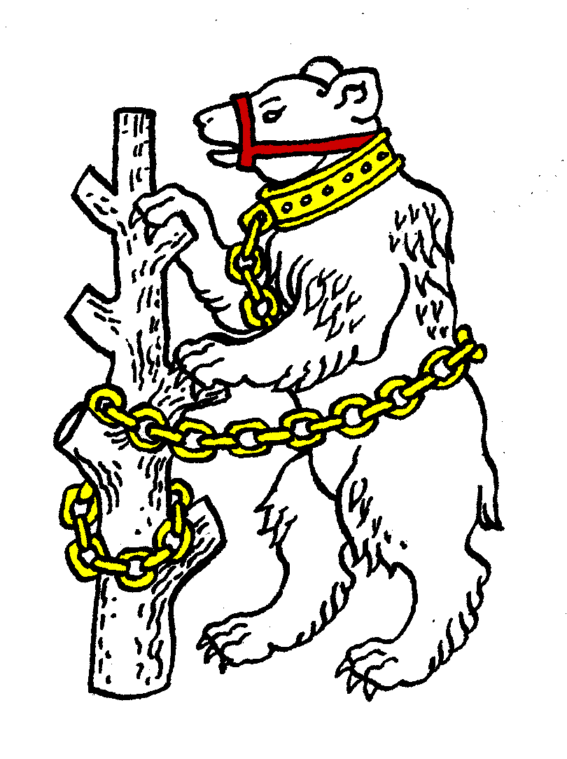
Warwickshire Table Tennis Association
Minutes of the Warwickshire Executive Committee Meeting held on Thursday 22 November 2012, at Kenilworth Wardens Cricket Club
Members present
Estyn Williams, Caroline Williams, Richard Grover, Tim Fell, Inky Moss, Neil Wheatley, Phil Paine, Malcolm Macfarlane and John Chandler.

- Apologies – Jo Outhwaite

- Minutes of the previous meeting 27 September 2012
Item 1 Apologies: change Adrian Pilgrim to Ian Ferguson.
The minutes were approved and signed as a correct record.

- Matters arising from the previous meeting
Item 6c: Alan White was not suspended.
Item 7: re Midland League – NW has written to Rob Sinclair to inform him that the Midland League requires all its players to be ETTA members. Similarly NW intends to suggest to Brian Aston that the heart of England League should only allow ETTA registered players.

- Results of the Warwickshire Trials and Talent Identification Day
Trials results were sent out by JO to MM. To be re-circulated by MM.

- General Secretary’s report and correspondence
ETTA Correspondence:
- Electronic communication – agreed that email would be acceptable but would want paper copies as well.
- Leslie Forrest Memorial Trophy – no nomination.
- National Council minutes and reports from 13 October 2012 meeting
- Up to date list of suspensions from Disciplinary Committee.
- Maurice Goldstein Merit Award – no nomination.
- Rule Book 2012/13

- Any other correspondence - none

- Financial report
£400 sponsorship received from Wheelers, to be used to purchase county shirts for Junior, Cadet & Veteran teams. Fees have been received from 4 leagues plus schools entries.
Tracksuits bought for Junior & Senior teams, featuring “Warwickshire” and the bear.
“Tournament Planner” purchased so that we can organise tournaments with fees paid via “PayPal”. Leamington League agreed to pay half of costs & Free Church may be interested.

- League reports
Birmingham – Lost 2 teams, one from Premier, one from Div 2. Bham Closed 20 January 2013, cup entries now in.
Leamington – lost 1 team, but will get 3 more at Xmas, 41 3aside, 23 2aside.
Stratford – 9 teams based at 4 venues.

- National Councillor’s report
Meeting 13 October 2012.
- Treasurer is to put a proposal to the Jan NC that fees should be increased, with the reward of a shopping card. EW advised him that he will need to sell this to the rank and file. Amendments may be allowed on this subject at 2013 AGM.
- Individual Membership. It is to be proposed that IM year will be altered to 1 August – 31 July, so fees will need to be paid by 1 August each year. Rules committee have agreed now to allow people to pay after 1 August, but not allowed to play.
- 2 emails from existing team stating that they are standing for re-election to ETTA
- Andy Seward, Richard Scruton, and a Treasurer to stand against them.
- EW suggests we ask people to give their comments on who to vote for.

- County Championships
Cadet: 2 matches Phoenix 8 December, it was agreed to pay for coffee, tea & squash.
Over 60: Colebridge v Worcs playing next Tuesday afternoon.
Junior: Cippenham 10/11 November lost all 3 unfortunately, 4-6, 4-6, 1-9. Particular problem is that the girls are very young & inexperienced.
Vets A: St. Neots 27/28 October won 1 out of 3 in a tough Div 2A.

- County Umpires
IM not able to attend trials. Player behaviour is getting worse so umpires have to be stricter.
- Coaching report
Girls training session booked, to be held at Rugby.
- Publicity report – no report
- West Midlands Regional Committee
Meeting held 27 September 2012. Helen Lower wishes to carry out training in each county.
Ping Brum was very successful, 6 July to 13 August, 64 tables. Survey showed that 4000 bats were used & tables 109,000 times. Received 2012 Project of the Year Award. Following this success, it may be extended to Solihull & Coventry in 2013.
- Warwickshire Team Championship
Only one entry was received, so agreed to let it drop.

- Schools report
JO emailed results of schools team competition. Suggested that JO could encourage teams to enter a 2-sided team in future to get match practice if only 2 girls.
- Webmaster – no report
- Arrangements for Warwickshire Closed Sunday 6 January 2013
Referee Clifford Bell from Staffs. CW, EW, JC, Bob Brown to help CB run tournament. RG to put results on laptop. Admin fee increased by 50p to cover cost of “Tournament Planner”. Loudspeaker could cost £750 to buy. Agreed to ask Bham if we could borrow their loudspeaker. No refreshments.
Email from Chris Maiden. Plays in Warks league but plays for Worcs in county champs. Agreed that under new rule agreed at the last meeting he cannot enter Warks Closed.

- AOB
Spotlight system to identify clubs – not good idea and looks likely to be ditched.

- Date of next meeting
Thursday 24 January 2013, 7.45pm at Kenilworth Wardens Club.

