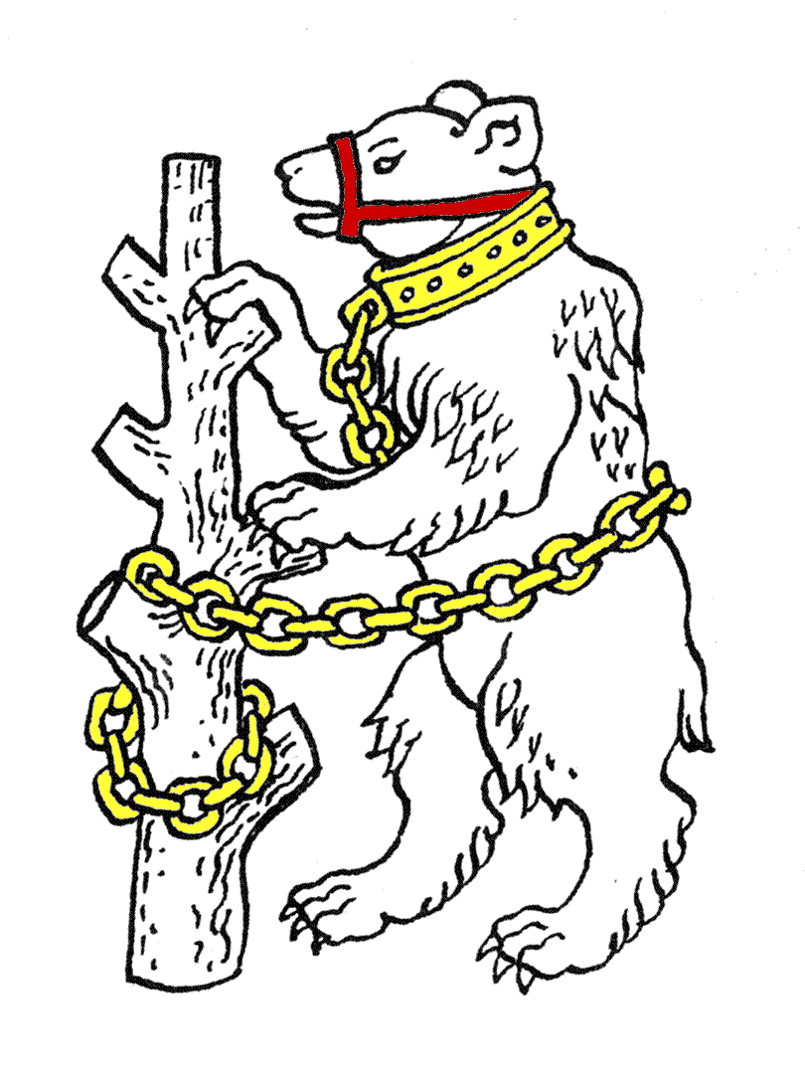
Warwickshire Table Tennis Association

Minutes of the 2009 Annual General Meeting

This was held at Kenilworth Wardens Cricket Club, Kenilworth, on Thursday 25 June 2009 at 7.30pm

Members present
Estyn Williams, Caroline Williams, Dave Palmer, Malcolm Macfarlane, John Chandler, Adrian Pilgrim, Don Pritchard, Jo Outhwaite.

A minutes silence was held in memory of Jim Whitehead, who had been a member of WTTA for many years and had died on 8 May 2009.

- Apologies
Geoff Taylor, Tim Fell.

- Minutes of the previous AGM meeting 26 June 2008
The minutes were approved and signed as a true record.

- Matters arising
Proposal to alter rules :- these were sent to ETTA for approval and were approved by ETTA. They are now posted on the WTTA website

- County Chairman’s report
- County Championships:- The Juniors won their division and move back up, cadets were able to maintain their place in the Cadet Premier, but the Seniors unfortunately are straight down from Division 1 whilst the Veterans and Over 60 had average seasons.
The motion put up by the County Championships committee to reduce girls from 2 to 1 we disagreed with as it is a bad advertisement for table tennis plus teenagers need 2 girls to socialise with at matches. We put up an alternative motion which was badly printed by the CC Committee, but their motion failed and our motion has been sent to ETTA Ladies table tennis working party. We have worries that it may be swamped but we will raise it at ETTA AGM.
Our aspiration should be to get all 5 age group teams into the Premier or 1st divisions.
- Warwickshire Closed:- the standard of organisation was very good and we are lucky to have MM to run it. It has every age group with over 70 introduced this season.
- Organisation:- most development has been in Rugby. Both Leamington and Birmingham have gone up in team sizes. Sadly Coventry again had not appointed a League ETTA representative, denying themselves and WTTA votes at the ETTA AGM.
We must congratulate DP on the website particularly with relation to ETTA Chairman elections.
Rugby (DP, JO & AP) have done lots of work on schools development, which is the way forward. Warwickshire Schools for table tennis is Coventry, Rugby, Solihull & Warwickshire (only excludes Birmingham).
- Coaching:- its very encouraging to see girls only coaching in Rugby.
- National Council:- Most important for ETTA nationally is the move to Individual Membership.
- ETTA Chairman election:- there were split views in WTTA, with different leagues voting for different candidates, though it was disappointing that there was little interest in the rest of the electorate.
- MM added:- Regarding girls not playing in County Championship matches, one of the biggest offenders is Surrey who have 46 ranked girls. However our Cadets did extremely well and our Seniors were unlucky not to stay up as they were very close. 2009/10 structure will give Senior A & B in same division so there could be a home fixture at Sydenham in November for some of their matches.

- County Treasurer’s report
Financially a very good year. We had a donation of £650 from Wheelers Timber for new team shirts and the team costs were comparatively cheap, so we finished with a huge excess of £995.80. Even allowing a reserve of £4,000 there is available £2,723 + £429 for schools, so we should consider what it could be used for such as county team coaching. MM will move some more monies into investment account and it was agreed to add CW to list of signatories. 2009/10 costs reasonable if Seniors play at Sydenham.
The AGM thanked the Treasurer for his good work, and approved the accounts.

- Rule Change propositions
- From the Executive Committee:
At the end of rule 9.1(3) add a new sentence:-
“Each Local League may also appoint a deputy representative who shall be entitled to attend and vote at an Executive Committee meeting in the absence of the representative”.
The motion was carried 8-0.
- There were no other rule change propositions.

- Motions - There were no motions.

- Election of President
Geoff Taylor was elected as President unopposed.

- Election of Chairman
Estyn Williams was elected as Chairman unopposed.

- Election of other Officers
The following officers were elected unopposed:
- Vice Chairman – Bob Montgomery
- General Secretary – Caroline Williams
- Treasurer – Malcolm Macfarlane
- County Match Secretary – Malcolm Macfarlane
- Publicity Secretary – Caroline Williams
- Competition Secretary – Geoff Taylor
- Umpires Secretary – Bob Montgomery
- Coaching Secretary – Adrian Pilgrim
- Webmaster – Don Pritchard

- Election of representatives of WTTA at the West Midlands Regional Committee of ETTA
Neil Wheatley and Malcolm Macfarlane were elected unopposed.

- Election of one person to represent schools table tennis
Jo Outhwaite was elected unopposed.

- Election of one person to represent clubs table tennis
Position vacant.

- Election of Life Members
Mrs Veronica Jackson and Mr George Halvorsen were confirmed to continue. In addition it was agreed that Mrs Thalia Whitehead should be made a Life Member in recognition of her service to WTTA. All three names are to be listed on the front page of WTTA Handbook.

- Election of Auditor for 2009/10
Bob Hughes was elected unopposed

- AOB
- Correspondence from ETTA regarding: -
- National Council
- BUSA
- Individual Membership
- AGM / EGM - fees issue. Agreed that WTTA to support Cleveland motion re fees.
- Annual report
- Maypole club
- Letter from Staffordshire TTA with request that Jessica Birbeck represents Staffordshire for 2009/10 – agreed no objection
- Emails from Susie Thompson requesting claim for Regional Trials costs plus a County Badge for her daughter Holly. ST had already been advised to contact Phil Paine re refunds. Agreed to award County badge to Holly and any others that are eligible. As running out of badges to investigate ordering lapel badges.
- Donation of £30 had been given to the Marie Curie Cancer Care in memory of Jim Whitehead.
- Email from John Arnold – passed to Jo Outhwaite.
- WTTA Trials. Agreed to be held last weekend in September 26/27.
- Warwickshire Closed Sunday 6 December agreed.
- WTTA Handbook – to be ready for Secretaries meetings in leagues so needs to be finished by end of August.

- Date of next WTTA AGM and next Committee meeting
AGM – Thursday 24 June 2010 at Kenilworth Wardens Club
Committee – Thursday 24 September 2009 at Kenilworth Wardens Club

