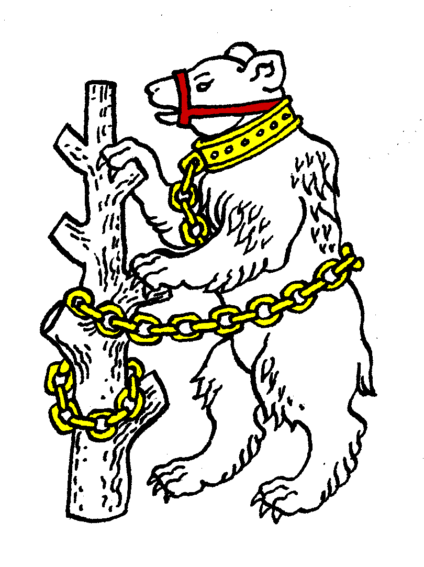
Warwickshire Table Tennis Association
Minutes of the Warwickshire Executive Committee Meeting held on Tuesday 19 March 2013, at Kenilworth Wardens Cricket Club
Members present
Estyn Williams, Caroline Williams, Peter Morris, Tim Fell, Ian Ferguson, Inky Moss, Neil Wheatley.
- Apologies – Jo Outhwaite, Phil Paine, Malcolm Macfarlane and John Chandler.

- Minutes of the previous meeting 24 January 2013
The minutes were approved and signed as a correct record.

- Matters arising from the previous meeting
Item 4: re Worcestershire rule – to be left to the next meeting as MM absent.
Item 8: Birmingham Closed will now be held in September 2013
Item 15: It was clarified that it was Colebridge Club’s Facebook page that had had derogatory comments posted on it. Colebridge have now set up rules to deal with this.

- General Secretary’s report and correspondence
ETTA Correspondence:
- Electronic communication – agreed that email and post should be requested.
- National Council 26 January 2013 – summary, chairman’s report plus 6 reports
- Election results for ETTA Chairman, Deputy Chairman and Treasurer
- Resignation of Richard Yule, ETTA Chief Executive
- List of Rule Change Propositions for ETTA AGM on 13 July: main proposition is to alter membership year so that it runs 1 August to 31 July in future years.
- Any other correspondence - none

- Financial report
See account sheets and comments page from MM.
EW stated that at next meeting, the fees for the next season should be considered.
IF will try to contact Wheelers Timbers (via Dawn Sagoo) in case MM has incorrect email.

- League reports
Birmingham – the system of inflicting penalties on teams not completing score cards correctly has been causing problems.
Leamington – Closed being held this Sunday, with Finals at Eathorpe in April
Nuneaton – Held Closed with 48 Juniors on the Saturday, adults on the Sunday. Only 6 clubs, with Juniors in two (Ambleside and The Crescent). They have nowhere to go to have a knock so difficult to encourage juniors. Problem at Closed final of U15 with a complaint by one of the players against the umpire who had called his serves. League is on 365 website, with all games up to date. Venues are the main problem for Nuneaton.
Stratford – final matches next week, and Shottery A have won the league. Cup Final may have to be delayed until April.

- National Councillor’s report
Last meeting was on 26 January 2013, next one is in late April. January main topics were:
- Funding from Sport England is in two parts. We get a reasonable deal from “Participation” but our “Elite” part is based on potential Olympic medals so £0. Sport England have awarded some money for one year and promised (but not guaranteed) for future years provided we answer specific questions correctly.
All Disability & Community Coaches are to be made redundant at the end of May.
- ETTA Affiliation fee to be increased to £8 from £6 is to be proposed at next AGM.
- Further discussions about coach licence system
- Andy Seward (newly elected Chairman) is nominating his Vice-Chairmen.
- EW confirmed that he voted as Warwickshire for Andy Seward as agreed.

- County Championships
See sheet. Cadets - won division so into Premier next season
Senior A – James Ward & Kate Hughes both won 10/14, team finished second in Div 1A, best performance despite missing their best player. Thanks to Dot Macfarlane for coming.
Email from Kate Hughes read out
Junior – demoted from Premier last season. Inexperienced team especially the girls, one of whom was a cadet and struggled against hard opposition.
Veterans – finished 6^{th.} Over 60 – finished 5th
IF reported that he was concerned about Amann Ubhi, who had not attended the Warwickshire Closed and turned down the County weekend 5 days prior despite three months notice. The committee reminded the Selection Committee that commitment is a relevant issue to be taken into account.

- County Umpires
IM reported that he had been at a Disability tournament so Dot Macfarlane had agreed to attend the county senior weekend as umpire. Pleased to see her back after absence.
- Coaching report
- Girls training session- cancelled by snow, still trying to rearrange.
- Helen Lower ran a workshop for coaches at Colebridge. IF to ask her to run one for Warwickshire coaches.
- Tom Brocklehurst and Chris Mulligan are planning to run quarterly coaching sessions between Free Church and Colebridge at alternate venues.
- IF is offering to go to clubs to help out with coaching

- West Midlands Regional Committee
- Lot of promotion of disability work
- YMCA Birmingham has had redundancies, & turned off heating at the sports centre. Suggested training centre for Warks Juniors should be considered to be held at YMCA.
- Not sure of position of ExtraPing.
- Schools report – no report
- Webmaster – no report
- AOB
- Agreed that closing time be put on minutes.
- Seniors B play this weekend at Rugby, expect to get promotion from division 2.
- U11,U14 Regional Qualification 6th/ 7th April at Wood Green.
- Alteration to ETTA rules may mean that the Midland League will not have to pay (as thought last year) to be a league “in good standing”.
- Date of next meeting
Tuesday 21 May 2013, 7.45pm at Kenilworth Wardens Club.
The meeting closed at 10.00 pm

