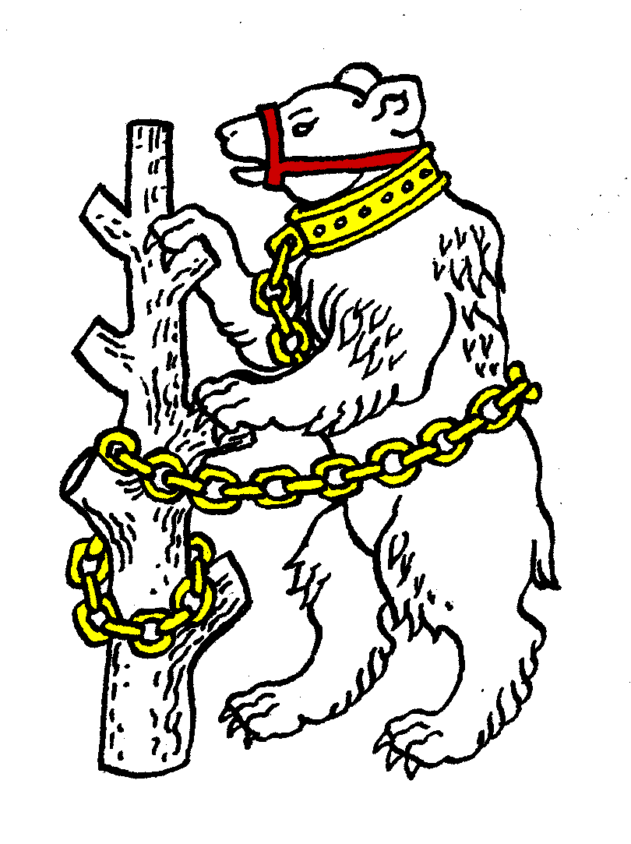
Warwickshire Table Tennis Association
Minutes of the Warwickshire Executive Committee Meeting held on Tuesday 29 November 2016, at Kenilworth Wardens Cricket Club
Members present
Estyn Williams, Caroline Williams, Ian Ferguson, John Chandler, Inky Moss, Neil Wheatley, Peter Morris, Jo Outhwaite, Malcolm Macfarlane.

- Apologies – Richard Grover, Ryan Stockham, Phil Paine, Mick Browne.

- Minutes of the previous meeting 27 September 2016
The minutes were approved and signed as a correct record.

- Matters arising from the previous meeting (apart from in agenda)
- Item 11b):- CW reported that she had contacted Kelly Sibley in case she had not been contacted about this season, but as expected she was not available on the dates.
- Item 4b): After discussion it was agreed to call it a Trial / Talent Identification Day.
- Item 4c): Revised document “Playing for Warwickshire” discussed and agreed. To be sent out with invite to Trial / TID. Key sentence in document (“Juniors and cadets are invited to attend a trial/talent ID day in early September which is an important factor, but not the only factor in choosing the team”) to be included in invite sent out.
- Item 4d & e): Invites for Trials / TID are sent to any individual in the age group who we know the email for (including associates) and to coaches, but not to club secretaries.

- Warwickshire Closed 8 & 15 January 2017
St. Nicholas has been booked until 6pm on both days. ‘Table Tennis Daily’ may be wanting to have a stand at St. Nicks – not a problem. See entry sheet.

- General Secretaries and other correspondence
Email from Jess Shepherdson, Oaks Consultancy, about re-development of Hampton-in-Argen Sports Club and possible table tennis interest. Agreed that we have no interest.

- Financial report
Lawrence Sheriff School, Rugby – we have now paid £500 of outstanding fees for our hire costs. Agreed that WTTA would give full support to the Vets team in the Premier division.

- Leagues report
B’ham – Going well. B’ham Closed March 12th 2017.
Leamington – going well. Championships 2 & 8 April 2017.
Nuneaton – league fixtures all up to date, same number of teams, 2 divisions (8 & 7) but all older players. However have 3 new Level 1 coaches who are active, with coaching on Friday evenings & Saturday mornings. Handicap league now held in spare weeks.
Stratford – 12 teams in 1 division.

- National Councillor’s report
- Meeting held on 5 November 2016. Sport England & GB Sport have brought out a new “Code of Governance” which all sports will have to comply with. New requirements appear to include a Board appointed Chairman (TTE articles will need amending) and NCs cannot serve more than 8 or 9 years, which may be applied retrospectively.
- National Council Chairman Tony Catt was keen to shorten the report section of the meeting so as to have 2 sections of group discussions, but it was not possible.
- Core funding is to be reduced whilst targeted funding is increased.

- County Championships’ report
- 2nd day for Juniors Div 1A to be held at St. Nicholas, Warwick on 3 December. Help needed to set up. Lost 2, drew 1 on 1st day.
- Senior – won 2, lost 1 already in Premier, next play 28/29 January
- Senior B struggled, losing all 3 in Div 1, next play end Jan.
- Vets all did well, won 2, lost 1 so far, next play 25/26 February
- Vets 2 new team, doing quite well so far in Div 3.
- Cadets 2nd day on 17 December, so far lost 2, won 1.
- B’ham university student (female) seen playing – could be strong enough for county.

- County Umpires’ report
Umpires now: DM, IM, GT, JO. Also ‘Josh’ and papers have gone to Richard Hancock.

- Coaching report
Senior coaching / practice has been set up at Hill St on the 2nd Friday of each month 8 to 10pm as a sort of county get-together. Made a £45 profit first time, given to WTTA.

- West Midlands Regional Committee – no committee meetings at present

- Warwickshire team championship 23 April 2017
NW has revised the rules for website & to be sent out with entry form in early March.

- Schools report
Team competition held on 16 November. Results: Girls – Under 11 Pearl Hyde; U/13 North Leamington; U/16 none; U/19 Tudor Grange (only now needs 2 players per team in this category, but still only 1 entry). Boys – Under 11 Pearl Hyde (uncontested); U/13 Lawrence Sherriff (5 entries); U/16 Ashlawn (3 entries); U/19 Lawrence Sheriff (1 entry) but mock A’s clash with next round so cannot proceed. John Arnold reports that TTE may take over the management of school’s competitions as the current committee are getting too old.
Individual championships to be held 20 January & 3 February.

- Webmaster report
The Committee was concerned that the Webmaster was not able to update the website at regular intervals, nor able to attend committee meetings. In addition there were other problems. As a result, the committee agreed that they felt that the Webmaster should be asked to resign, to allow the job to be done by someone else.

- Welfare report – update given.
- AOB
- IF asked about the seedings for the county championships, which was resolved.
- Mark Jackson’s mother had died on 11 November 2016. CW to email condolences.

- Date of next meeting
Tuesday 10 January 2017, 7.45pm at Kenilworth Wardens Club.

The meeting closed at 9.58pm.

