RULES

1. All participating Schools and Colleges must be affiliated to the W.S.T.T.A. via registration (entry) fees* of £12 per team.
2. Four players per team to play in ranked order. All players must be in FULL TIME education. No mixed teams.
3. Eight team events - Boys under 19, 16, 13 and 11, and Girls under 19, 16, 13, and 11.
4. Qualifying date for ages is the school year. e.g. U11 is year 6 and below, U13 year 8 and below and so on.
5. Entries to the event organiser Jo Outhwaite – address overleaf.
6. Closing date for entries is Tuesday 17th November 2015.
7. Team captains, or teachers in charge, should report at 5.45pm when the doors open. Play is from 6pm to, approximately, 9pm.
8. Late arrivals holding up the competition may be scratched.
- Sports attire MUST be worn. NO WHITE CLOTHING.
- Matches will be played best of 5 games 11 points up, changing service after every 2 points wherever possible.
- This event starts with groups and in the latter stages is a knockout, though there will be consolation play-offs if time permits. The approximate finish time is, obviously, for the most successful teams!

All winning teams will go on to the Zone Team Finals at Wood Green Academy on Saturday 30th or Sunday 31st January 2016
Likely split Sat U11 & U13
Sun U16 & U19

WARWICKSHIRE SCHOOLS
TABLE TENNIS CHAMPIONSHIP

TEAM CHAMPIONSHIPS

Thursday 19th November 2015

Lawrence Sheriff School, Clifton Road, Rugby CV21 3AG

Doors 5.45pm. Play from 6-9pm approximately.
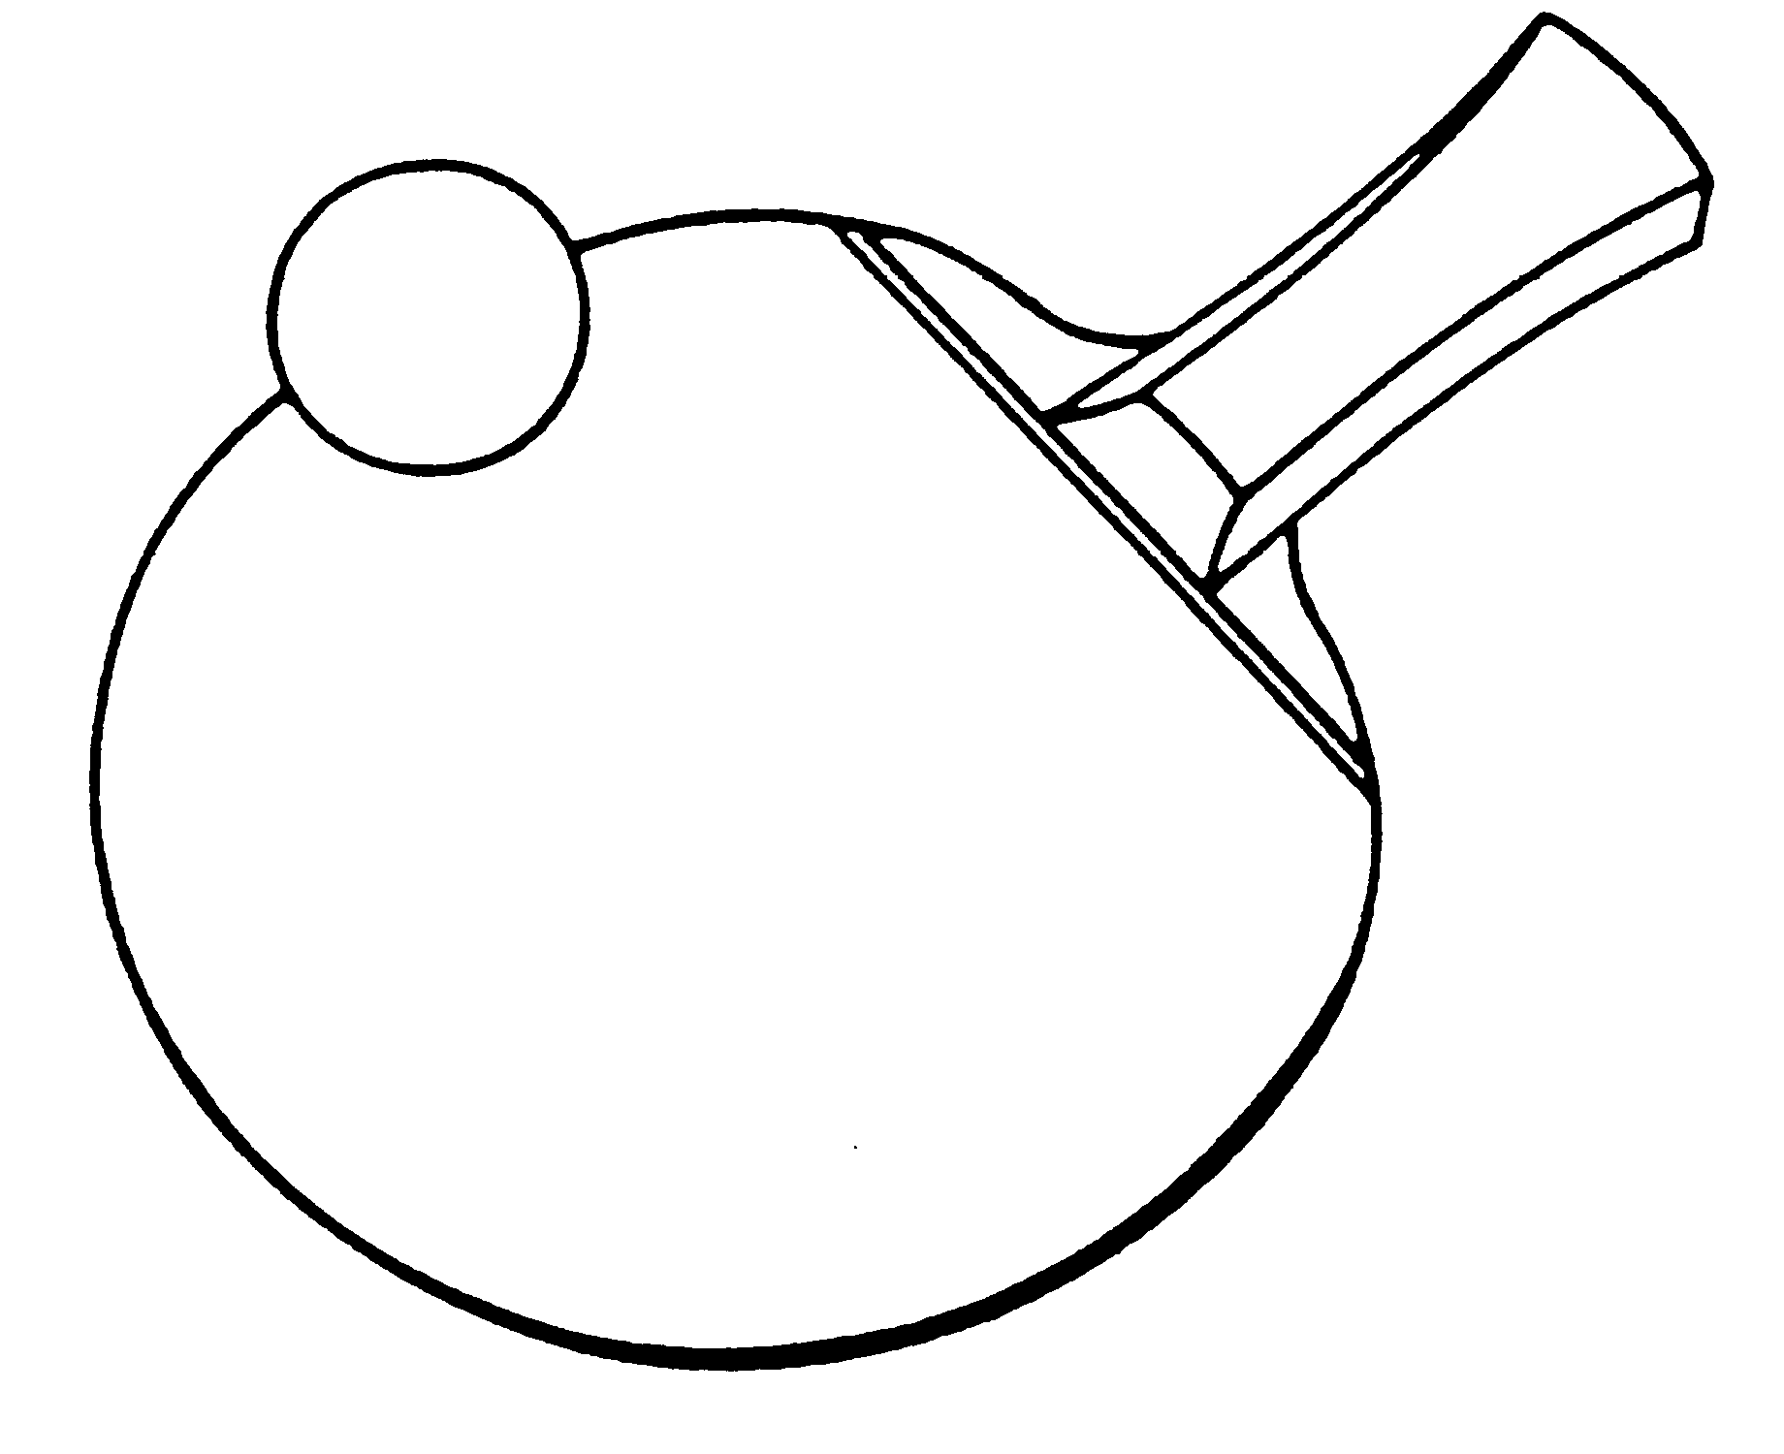

Closing date for entries is Tuesday 17th November

The Individual Warwickshire Schools Championships are on Friday 15th January for U11 Boys, U13 Boys & ALL Girls and Thursday 28th January for U16 Boys & U19 Boys

Event Organiser

Jo Outhwaite, 28a Stanley Road, Rugby, Warwickshire CV21 3UE
Tel: M 07799650635
E-mail: warwickshireschoolstabletennis@gmail.com


Rugby Table Tennis Centre,
Lawrence Sheriff School, Clifton Road, Rugby CV21 3AG
From A45 (Leamington)
Come off A45 head north on A4071 (Bilton Road) into Rugby.
Up hill into town then bear right at gyratory system/roundabout for the A428 (Hillmorton Road) for about half a mile when you come to the big roundabout on Hillmorton Road (you can see the school playing field on the left).
Turn left at this roundabout, left at the next roundabout and then almost immediate left into front of school.
Park! The new building in front of you is the Table Tennis Centre. If there is nowhere here to park then there are other car parks at the school.

From the North
Come off M1 at junction 20 take third exit to Rugby.
Follow the dual carriageway for about 1.5 miles; keep in the left hand lane! Go straight over the first roundabout.
You begin to go downhill, go straight over another roundabout.
At the next roundabout (it has Kipling written in the bricks around the edge!) turn left (signposted "Picnic Area"!!)
After you turn left you'll see the canal and picnic area on the right.
Keep straight on; over a mini-roundabout.
Go over the canal as the 30mph sign comes up.
Past a few shops which are on the left. Old garage on right.
Turn right at lights (Mill Road). You'll come to a tunnel (under the railway station) - go through the tunnel and straight up the hill - this is called Murray Road.
At the top of Murray Road is a roundabout, you can see the school, to the right, on the other side of the roundabout.
Take the fourth exit (e.g. right) and then indicate left to turn almost immediately into the front of the school.

From the South
Come off M1 at junction 18. Take the A428 (West) Signposted to Rugby.
4.5 miles from the motorway you come to a roundabout turn right (Whitehall Park & the town Sports Centre are on the left.)
In 100 yards, at the next roundabout, turn left and keep indicating left to turn immediately into the front of the school.

Warwickshire Schools Table Tennis Team Championships

ENTRY FORM This will be acknowledged if sent electronically.
Name of School
Address of School

Post Code Tel No
Teacher in charge
Home Address (for emergency contact)

Post Code Tel No
eMail address @

EVENTS
1. Please enter team/s in the Boys under 19 event
2. Please enter team/s in the Girls under 19 event
3. Please enter team/s in the Boys under 16 event
4. Please enter team/s in the Girls under 16 event
5. Please enter team/s in the Boys under 13 event
6. Please enter team/s in the Girls under 13 event
7. Please enter team/s in the Boys under 11 event
8. Please enter team/s in the Girls under 11 event
* I enclose registration fee of £12 per team £
Total £

Cheques should be made payable to “Warwickshire TTA”

Return form and/or make any enquiries to :-

Jo Outhwaite, 28a Stanley Road, Rugby, Warwickshire CV21 3UE
Tel: M 07799650635
E-mail: warwickshireschoolstabletennis@gmail.com
Entries also accepted by confirmed email

